CHAPTER 01
INTRODUCTIONsn
Introduction
Efficient inventory control is one of the most essential aspects of running a successful retail business, especially in the grocery sector where products move rapidly and many items have limited shelf life. Traditional approaches — such as manual stock entry, paper-based logs, or spreadsheets — are often inaccurate, time-consuming, and lead to challenges like mismatch in stock levels, delayed restocking, and excess workload for staff.To overcome these limitations, an automated and centralized Inventory Management System is required.
Objective
- Accurate Stock Monitoring: Updating available stock immediately after purchase or sale to avoid shortages and overstock.
- Reduction of Manual Work: Eliminating traditional handwritten registers and spreadsheets, minimizing human calculation errors.
- Role-Based Access: Providing separate dashboards and permissions for Admin, Staff, and Suppliers.
- Faster Billing: Generating invoices automatically and maintaining digital sales records.
- Better Decision Making: Offering data and reports that help owners analyze business performance.
Proposed System
The proposed system digitalizes inventory operations using the MERN Stack — MongoDB, Express.js,React.js and Node.js.
It offers:
A user-friendly web interface, Cloud-based data storage, Secure authentication, Realtime product tracking, Automatic alerts for low stock, Billing and reporting module. This approach reduces human dependency, saves time, improves accuracy, and ensures the store always maintains the right stock levels.

Modules included in this project
- User Authentication Module: Login for Admin, Staff, and Suppliers with separate permissions.
- Admin Module:Complete control over products, users, suppliers, and sales reports.
- Staff Module:Handles sales, adds products to cart, and generates bills.
- Inventory Management Module: Adds, edits, deletes, and categorizes products; tracks stock levels.
- Supplier Module:Receives restock requests and confirms delivery.
- Billing & Reporting Module:Creates invoices and displays analytical charts.
- Low Stock Module: Shows items that require restocking.
Problem Statement:
Running a grocery store without automation creates several difficulties such as:
- Inability to know real-time stock availability
- Slow and error-prone billing
- No proper record of suppliers and purchases
- Poor communication during restocking
- Lack of historical sales data for decision-making
This project resolves these problems by introducing a modern inventory management system that makes operations faster, clearer, and more reliable.

CHAPTER02
SYSTEM REQUIREMENTS

HARDWARE AND SOFTWARE REQUIREMENTS

- Hardware Requirements

- System Type Laptop/Desktop Computer

- Processor 11th Gen Intel(R) Core(TM) i3-1115G4 @ 3.00GHz 3.00 GHz
- Hard Disk (SSD) 474GB

- Monitor 1920 x 1080, 60.03 Hz
- Mouse Wired/Wireless

- RAM 4 GB minimum (8 GB reommended)

- Software Requirements

- Operating system: Windows 11 Home Single Language.
- Frontend: React.js
- Backend: Node.js with Express.js
- Database: MongoDB
- Web Browser: Google Chrome, Mozilla Firefox, or Edge
- Tools/IDE: VS Code, Postman for API testing, npm for package management
- Other Dependencies: RESTful APIs for communication between frontend and

CHAPTER 03
SYSTEM DESIGN

FEASIBILITY STUDY
A feasibility study is carried out to determine whether a proposed system is practical, beneficial, and worth implementing. It evaluates different factors to understand if the project can be completed successfully with the available time, technology, and resources. The study also identifies challenges, risks, strengths, and limitations before the development process begins. By analyzing aspects such as cost, technical requirements, workforce effort, and operational needs, the feasibility study helps decision-makers decide whether the project should move forward.
ECONOMICAL FEASIBILITY:
The Inventory Management System proves to be economically efficient because it reduces both manual effort and administrative expenses. In traditional inventory handling, employees manually update stock lists, prepare bills, and maintain paper files or spreadsheets. These tasks are slow, error-prone, and often lead to financial losses from incorrect billing, wrong stock entriesor delayed restocking. By replacing manual operations with an automated system, the chances of such errors are minimized. The system stores product details, sales data, and supplier records in a single database, which saves time and eliminates duplicate work.
Automated billing speeds up checkout, maintains accuracy, and prevents calculation mistakes. Low-stock alerts ensure timely replenishment, reducing the chance of empty shelves or expired stock. In addition, the system generates reports and analytics that help store owners plan purchases and forecast demand.
Therefore, the system cuts down operational costs, increases work productivity, and offers a long-term financial advantage, making it a profitable investment for small and large retail businesses. PAGE 4

TECHNICAL FEASIBILITY:
The system is technically achievable through the MERN stack, which includes React.js, Node.js, Express.js, and MongoDB. MongoDB offers a scalable and fast database for managing stock, billing, and supplier information. Node.js and Express.js handle server-side operations and enable smooth communication between the client and server using REST APIs.
React.js gives a dynamic, user-friendly interface that works efficiently on desktops, laptops, and mobile devices.
No high-end hardware is required—any standard computer with basic specifications can run the system without performance issues. Development tools such as Visual Studio Code, npm, and Postman provide a stable environment for coding, debugging, and testing.
The architecture also supports future improvements such as new modules, barcode integration, or third-party APIs. Role-based login keeps sensitive information protected.
Overall, the system is technologically stable, secure, reliable, and easy to maintain, proving its technical feasibility.
SOCIAL FEASIBILITY:
Social feasibility evaluates how well the system fits into the user environment. The Inventory Management System improves the work process for staff, makes administrative work easier for the store owner, and enhances customer service.
Admins can monitor stock, suppliers, and sales in one platform, reducing confusion and delays. Employees can quickly search product details and generate bills, which decreases waiting time for customers and prevents billing mistakes. Accurate inventory tracking ensures that essential products are always available, leading to better customer satisfaction.
By reducing repetitive tasks such as manual entry or stock counting, employees can focus on more useful and productive activities. The system also improves transparency in billing and stock handling, which creates trust among staff and management.Overall, the system positively impacts everyday store operations and benefits both employees and customers.

- USERS (ADMIN/STAFF) LOGIN:
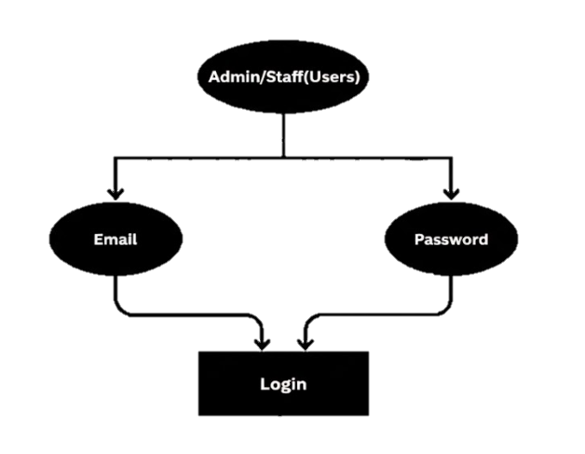
- USERS (SUPPLIER) REGISTRATION:
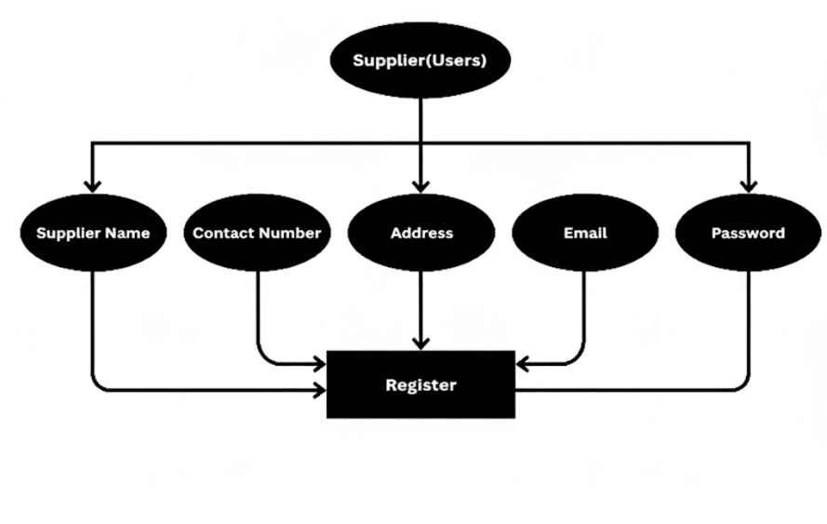
BU/DAMS/MCA-IV SEM PAGE 6
INVENTORY MANAGEMENT SYSTEM 2025-2026
USERS (SUPPLIERS) LOGIN:
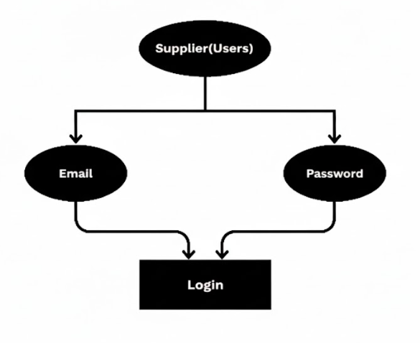
SUPPLIERS DASHBOARD:
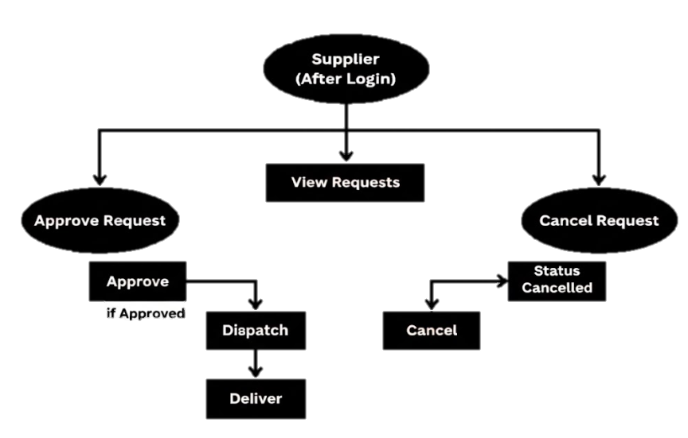
PAGE 7
STAFF DASHBOARD:
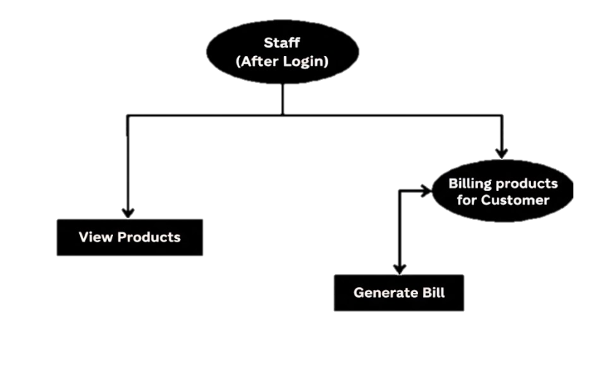
ADMIN DASHBOARD:
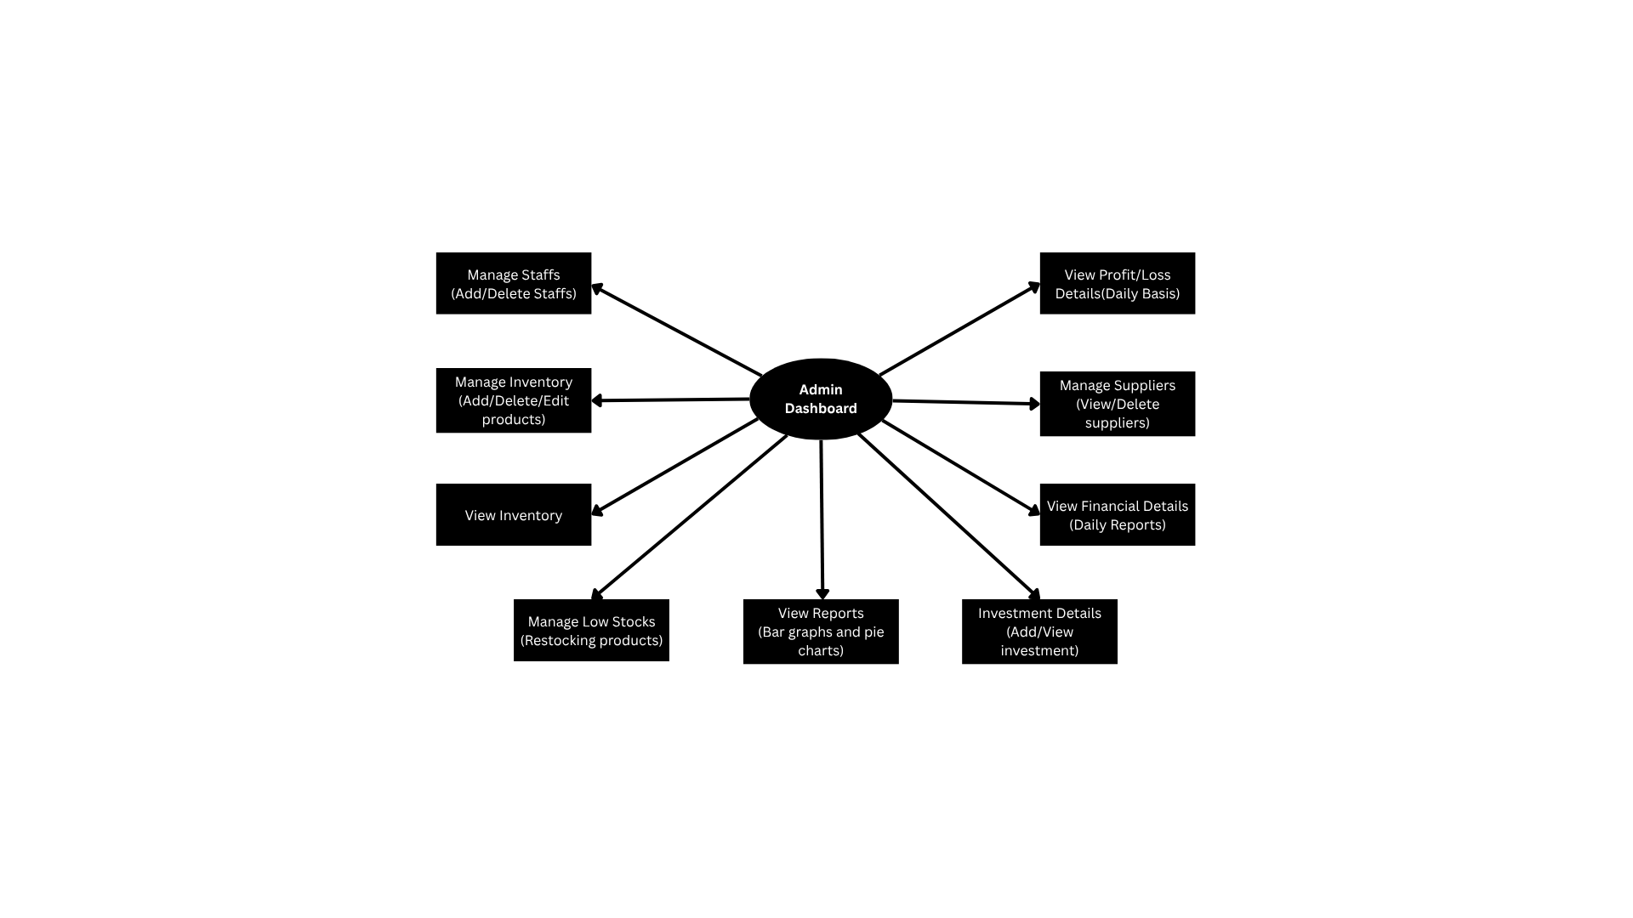

BU/DAMS/MCA-IV SEM PAGE 8
CHAPTER 04
IMPLEMENTATION

PLATFORM SELECTION
- VISUAL STUDIO CODE:

History:
Visual Studio Code, commonly known as VS Code, was introduced by Microsoft in April 2015 and officially launched later the same year as a free, open-source, and cross-platform code editor. It was developed using the Electron framework, which combines Chromium and Node.js, allowing developers to build desktop applications using web technologies.This approach allowed VS Code to run efficiently on Windows, macOS, and Linux, which was a major shift from Microsoft’s earlier tools that were mostly limited to Windows.In its early stages, VS Code was designed as a lightweight coding tool, but its powerful extensions and growing feature set quickly made it popular among developers worldwide. Today, it stands as one of the most widely used editors for web development, scripting, and software engineering.
Overview:Visual Studio Code provides a lightweight interface while still offering features commonly found in full-scale IDEs. It supports:
- IntelliSense for intelligent code suggestions, highlighting, and documentation lookup
- Built-in debugging, allowing developers to set breakpoints, inspect variables, and track execution without leaving the editor
- Extensions marketplace, enabling support for many languages and frameworks, including JavaScript, Node.js, and React
Because of these capabilities, VS Code is highly suitable for building applications using the MERN stack. It helps streamline development, debugging, code formatting, and version control, making it an efficient choice for developers.

BU/DAMS/MCA-IV SEM PAGE 9
- MongoDB:

History:
MongoDB was created in 2007 by Dwight Merriman, Eliot Horowitz, and Kevin Ryan while working on large-scale data processing challenges at DoubleClick. They realized that traditional relational databases were too rigid for handling fast-changing and unstructured data. To address this, they developed a new database model capable of handling large volumes of flexible data efficiently. In 2009, MongoDB was officially launched by their company, originally named 10gen, which later became MongoDB Inc.
The name comes from the word “humongous,” symbolizing its purpose of managing huge datasets. Over time, MongoDB grew into one of the most popular NoSQL databases used across the world for scalable and modern applications.
Overview: MongoDB is an open-source, NoSQL database that stores information in a document-based structure instead of traditional tables and rows. Data is kept in BSON (Binary JSON) format, allowing each document to have its own structure and fields.
Its key features include:
- High performance and real-time processing.
- Flexibility for storing dynamic or complex data.
- Indexing and aggregation for fast queries.
- Replication and sharding for distributed storage and high scalability.
Because it integrates smoothly with Node.js and Express.js, MongoDB plays a major role in the MERN stack. It is commonly used in inventory systems, healthcare platforms, e-commerce applications, and cloud-based services where fast storage and large datasets are required.

DATABASE DESIGN
- USERS COLLECTION
{
"modelName": "User",
"collectionName": "users",
"schemaOptions": {"timestamps": true},
"fields": {
"name": {"type": "String","required": true},
"email": {"type": "String","required": true,"unique": true}, "password": {"type": "String","required": true}, "role":{"type":"String","enum":["admin","staff"],"default":"staff}, "createdAt": {"type": "Date"}, "updatedAt": {"type": "Date"}
}
}

- CATEGORIES COLLECTION
{
"modelName": "Category", "collectionName": "categories", "schemaOptions": {"timestamps": true}, "fields":{ "name":{"type":"String","required":true,"unique":true}, "shelfLife": {"type": "Number","required": true,}, "createdAt": {"type": "Date",timestamps”:true"}, "updatedAt": {"type": "Date","autoGenerated": true}
}
}

- PRODUCTS COLLECTION
{
"modelName": "Product",
"collectionName": "products",
"schemaOptions": {"timestamps": true},
"fields": {
"name": {"type": "String","required": true},
"category": {"type": "ObjectId","ref":"Category","required":true}, "unit":{"type": "String","required": true}, "pricePerUnit": {"type": "Number","required": true}, "purchaseCost": {"type": "Number","required": true,"default":0}, "quantityAvailable": {"type": "Number","required": true}, "isDivisible": {"type": "Boolean","default": true}, "image": {"type": "String"}, "createdAt": {"type": "Date","default": "Date.now"}, "expiryDate": {"type": "Date","required": false}, "updatedAt": {"type": "Date","autoGenerated": true}
}
}

- STOREORDERS COLLECTION
{
"modelName": "StoreOrder", "collectionName": "storeorders", "schemaOptions": {},"fields": { "productId":{"type":"ObjectId","ref":"Product","required":true} "supplierId":{"type":"ObjectId","ref":"Supplier","required":true}, "quantity": {"type": "Number","required": true}, "unit": {"type": "String"}, "totalAmount": {"type": "Number"}, "status":{"type":"String","enum":["Pending","Approved", "Cancelled","Dispatched","Delivered"],"default":"Pending"}, "paymentStatus": {"type": "String","enum": ["Unpaid","COD", "Online","Received"],"default": "Unpaid"}, "createdAt": {"type": "Date","default": "Date.now"}
}
}

- ORDERS COLLECTION
{
"modelName": "Order", "collectionName": "orders", "schemaOptions": {"timestamps": true},"fields":{ "customer":{"type":"ObjectId","ref":"Customer”,"required":true}, "items":{"type":"Array","subSchema":{"product":{"type":"ObjectId", "ref": "Product","required": true}, "quantity": {"type": "Number","required": true}, "price": {"type": "Number","required": true}}}, "totalAmount": {"type": "Number","required": true}, "profit": {"type": "Number","default": 0}, "orderDate": {"type": "Date","default": "Date.now"}, "createdAt": {"type": "Date","autoGenerated": true}, "updatedAt": {"type": "Date","autoGenerated": true}
}
}

- CUSTOMERS COLLECTION
{
"modelName": "Customer", "collectionName": "customers", "schemaOptions": {"timestamps": true}, "fields": { "name": {"type": "String","required": true}, "phone":{ "type": "String","unique": true,"required":true}, "createdAt": {"type": "Date","autoGenerated": true}, "updatedAt": {"type": "Date","autoGenerated": true}
}
}

- SUPPLIERS COLLECTION
{
"modelName": "Supplier", "collectionName": "suppliers", "schemaOptions": {"timestamps": true}, "fields":{
"supplierName": {"type": "String","required": true,"trim": true}, "contact": {"type": "String","required": true}, "email": {"type": "String","trim": true}, "address": {"type": "String","trim": true}, "productsSupplied":{"type":"Array","items":{"type":"String"},"default":[]}, "password": {"type": "String","required": true}, "role": {"type": "String","default": "supplier"}, "createdAt": {"type": "Date","autoGenerated": true}, "updatedAt": {"type": "Date","autoGenerated": true}
}
}

CODES
Navbar.js
import React from "react";
import { useNavigate, useLocation } from "react-router-dom";
import "../CSS/Navbar.css";

const Navbar = () => {
const navigate = useNavigate();
const location = useLocation();
const hideBtn = ["/login"]
const hideBtnFor = hideBtn.includes(location.pathname);

const handleLogout = () => {
localStorage.removeItem("token");
localStorage.removeItem("userRole");
navigate("/login");
};

const handleNavigate = () => {
navigate("/about")
}

return (
<nav className="navbar">
<div className="navbar-logo">
<h2>InventorySys</h2>
</div>
<div className="buttons">
<button className="back-btn" onClick={handleNavigate}><img src="./images/info-button.png" alt="" /></button>
{!hideBtnFor&&<button onClick={handleLogout} className="logout-btn">Logout</button>}
</div>
</nav>
);
};

export default Navbar;

WelcomePage.js
import React from "react";
import { useNavigate } from "react-router-dom";
import "../CSS/WelcomePage.css";

const WelcomePage = () => {
const navigate = useNavigate();

return (
<div className="welcome-container">
<div className="welcome-content">
<h1>🌿 Inventory Management System</h1>
<p>Efficiently manage your store’s stock with ease and accuracy.</p>
<button onClick={() => navigate("/login")} className="login-btn">
User?
</button>
<button onClick={() => navigate("/sup-login")} className="login-btn">
Supplier?
</button>
</div>
</div>
);
};

export default WelcomePage;

Login.js
import React, { useState } from 'react'
import "../CSS/Login.css"
import { useNavigate } from 'react-router-dom';
import API from "../services/api"

const Login = () => {
const [email, setEmail] = useState("");
const [password, setPassword] = useState("");
const [error, setError] = useState("");
const navigate = useNavigate();

const handleLogin = async (e) => {
e.preventDefault();
try {
const res = await API.post("auth/login", { email, password });
localStorage.setItem("token", res.data.token);
localStorage.setItem("userRole", res.data.role);
console.log("res data = ", res.data.role);
if (res.data.role === "admin") {
navigate("/admin-dashboard")
}
else if(res.data.role === "staff"){
navigate("/staff-dashboard")
}
else {
navigate("/")
}
} catch (error) {
setError(error.response?.data?.message || "Login Failed!")
}
}
return (
<div className='login-container'>
<form className='login-form' onSubmit={handleLogin}>
<h1>Login</h1>
<input type="email" placeholder='Enter email' value={email} onChange={(e) => setEmail(e.target.value)} required />
<input type="password" placeholder='Enter password' value={password} onChange={(e) => setPassword(e.target.value)} required />
<button type="submit">Login</button>
{error &&<p>{error}</p>}
</form>
</div>
)
}

export default Login;

StaffDashboard.js
import React from "react";
import "../../CSS/StaffDashboard.css";
import { useNavigate } from "react-router-dom";
const StaffDashboard = () => {
const navigate = useNavigate();
return (
<div className="staff-dashboard">
<h1>Staff Dashboard</h1>
<div className="staff-cards">
<div className="card" onClick={() => navigate("/view-products")}>View Products</div>
<div className="card" onClick={() => navigate("/staff/billing")}>Billing</div>
</div>
</div>
);
};
export default StaffDashboard;

BillingForm.js
import React, { useState, useEffect } from "react";
import API from "../../services/api";
import "../../CSS/BillingForm.css"
import Searchbar from "../../components/Searchbar";
import html2canvas from "html2canvas"

const BillingForm = () => {
const [name, setName] = useState("");
const [phone, setPhone] = useState("");
const [products, setProducts] = useState([]);
const [cart, setCart] = useState([]);
const [order, setOrder] = useState(null);
const [message, setMessage] = useState("");
const [filteredProducts, setFilteredProducts] = useState([]);

useEffect(() => {
const fetchProducts = async () => {
try {
const res = await API.get("/products");
setProducts(res.data);
setFilteredProducts(res.data);
} catch (err) {
console.error("Error fetching products:", err);
}
};
fetchProducts();
}, []);

const addToCart = (product) => {
const existing = cart.find((item) =>item.product._id === product._id);
if (existing) {
setCart(
cart.map((item) =>
item.product._id === product._id
? { ...item, quantity: item.quantity + 1 }
: item
)
);
} else {
setCart([...cart, { product, quantity: 1 }]);
}
};

const updateQuantity = (id, qty) => {
setCart(
cart.map((item) =>item.product._id === id ?{ ...item, quantity: qty } : item

)
);
};

const removeFromCart = (id) => {
setCart(cart.filter((item) =>item.product._id !== id));
};

const handleBilling = async () => {
try {
const orderData = {
name,
phone,
items: cart.map((item) => ({
productId: item.product._id,
quantity: item.quantity,
})),
};

const res = await API.post("/orders", orderData);
setMessage("Bill generated successfully!");
setOrder(res.data); // store order for invoice
setCart([]);

setTimeout(() => {
sendWhatsappBill(phone);
}, 2000);

setName("");
setPhone("");
} catch (error) {
setMessage("Error generating bill");
console.error(error);
}
};

const sendWhatsappBill = async (phone) => {
try {
const invoicediv = document.querySelector(".invoice")
if (!invoicediv) return alert("Invoice Not Found")
//capturing image as image
const canvas = await html2canvas(invoicediv)
const imageBase64 = canvas.toDataURL("image/png").split(",")[1];
const uploadRes = await API.post("/imgbb/upload", {imageBase64});
const imageUrl = uploadRes.data.imageUrl;
await API.post("/whatsapp/send-whatsapp", {phone, imageUrl,})
alert(`Bill sent successfully to WhatsApp number: ${phone}`);
} catch (error) {
console.error("Error sending WhatsApp message:", error);
alert("Error sending bill to WhatsApp.");
}
}
const handlePrint = () => {
window.print();
};
return (
<div className="billing-container">
<h2>Customer Billing</h2>
{/*Reusable searchbar component */}
<Searchbar data={products} onSearch={setFilteredProducts} />
{!order ? (
<>
{/* Customer Details */}
<div className="customer-form">
<input
type="text"
placeholder="Customer Name"
value={name}
onChange={(e) => setName(e.target.value)}
/>
<input
type="text"
placeholder="Phone Number"
maxLength="10"
minLength="10"
value={phone}
onChange={(e) => setPhone(e.target.value)}
/>
</div>
{/* Products */}
<h3>Products</h3>
<div className="product-list">
{filteredProducts.map((p) => (
<div key={p._id} className="product-card">
<h4>{p.name}</h4>
<p>₹{p.pricePerUnit}/{p.unit}</p>
{p.quantityAvailable>0 ? (
<button onClick={() => addToCart(p)}>Add</button>
) : (
<span style={{ color: "red", fontWeight: "bold" }}>Out of Stock</span>
)}
</div>
))}
</div>
<h3>🛒 Cart</h3>
{cart.length === 0 ? (
<p>No items in cart</p>
) : (
<table className="cart-table">
<thead>
<tr>
<th>Product</th>
<th>Qty</th>
<th>Price</th>
<th>Total</th>
<th></th>
</tr>
</thead>
<tbody>
{cart.map((item) => (
<tr key={item.product._id}>
<td>{item.product.name}</td>
<td>
<input
type="number"
min="0.1"
step="0.1"
value={item.quantity}
onChange={(e) =>
updateQuantity(item.product._id, parseFloat(e.target.value))
}
/>
</td>
<td>₹{item.product.pricePerUnit}</td>
<td>
₹{item.product.pricePerUnit * item.quantity}
</td>
<td>
<button onClick={() => removeFromCart(item.product._id)}>
&#10060;
</button>
</td>
</tr>
))}
</tbody>
</table>
)}
<h3>
Total: ₹
{cart.reduce(
(sum, item) =>
<h3>
Total: ₹
{cart.reduce(
(sum, item) =>sum + item.product.pricePerUnit * item.quantity,0
)}
</h3>
<button className="generate-btn" onClick={handleBilling}>Generate Bill</button>
{message &&<p className="message">{message}</p>}
</>
) : (
<>
{/* Printable Invoice */}
<div className="invoice">
<h2>Invoice</h2>
{/* <p><strong>Customer:</strong> {order.customer.name}</p>
<p><strong>Phone:</strong> {order.customer.phone}</p> */}
<p><strong>Date:</strong> {new Date(order.orderDate).toLocaleString()}</p>
<table className="bill-table">
<thead>
<tr>
<th>Product</th>
<th>Qty</th>
<th>Price</th>
<th>Total</th>
</tr>
</thead>
<tbody>
{order.items.map((item, i) => (
<tr key={i}>
<td>{item.product.name}</td>
<td>{item.quantity}</td>
<td>₹{item.price}/{item.product.unit}</td>
<td>₹{item.price * item.quantity}</td>
</tr>
))}
</tbody>
</table>
<h3>Grand Total: ₹{order.totalAmount}</h3>
<p>Thank you! Visit Again &#128591;</p>
<button className="print-btn" onClick={handlePrint}>Print Invoice</button>
</div>
</>
)}
</div>
);
};
export default BillingForm;

About.js
import React from "react";
import "../CSS/About.css";

const About = () => {
return (
<div className="about-wrapper">
<section className="about-hero">
<div className="overlay"></div>
<div className="hero-text">
<h1>Inventory Management System</h1>
<p>Smart & Scalable Inventory Store Management — Simplifying Everyday Operations</p>
</div>
</section>
<section className="about-section fade-in">
<h2>About the Project</h2>
<p>
The <strong>Inventory Management System</strong> is built to streamline
grocery operations by connecting <b>Admins</b>, <b>Suppliers</b>,
<b> Staff</b>, and <b>Workers</b> through a unified digital platform.
It tracks stock levels, manages supplier orders, generates reports, and
ensures smooth coordination — all in one place.
</p>
</section>
<section className="roles-section fade-in">
<h2>Meet the Key Roles</h2>
<div className="role-cards">
<div className="role-card">
<img src="https://www.roberthalf.com/content/dam/roberthalf/images/blogs/us/en/migrated-blogs/hr1/high-paying-administrative-jobs-rh-2018.jpg" alt="Admin" />
<h3>Admin</h3>
<p>
Manages the entire system — oversees staff, maintains supplier relationships,
tracks reports, and ensures everything runs smoothly.
</p>
</div>
<div className="role-card">
<img src="https://importanything.ph/wp-content/uploads/2024/12/diverse-warehouse-employee-analyzing-goods-logistics-1200x800.jpg" alt="Supplier" />
<h3>Supplier</h3>
<p>
Handles restock requests, product delivery, and maintains
product availability for the grocery store.
</p>
</div>
<div className="role-card">
<imgsrc="https://t4.ftcdn.net/jpg/02/63/76/75/360_F_263767541_MP04Nw3RwWewgF8FmdRtx3OzEQZOo1w0.jpg" alt="Staff" />
<h3>Staff</h3>
<p>Views product details, manages billing, and helpsin daily sales operations.</p>
</div>
<div className="role-card">
<img src="https://generalworkforce.com/wp-content/uploads/2023/07/inventory-clerk1.jpg" alt="Worker" />
<h3>Worker</h3>
<p>Assists in physical product handling, labeling, and helps maintainaccurate in-store stock.</p>
</div>
</div>
</section>
<section className="features-section fade-in">
<h2>System Highlights</h2>
<div className="features-grid">
<div className="feature">
<h4>&#128230; Real-time Stock Tracking</h4>
<p>Instant alerts and live data updates for low or restocked inventory.</p>
</div>
<div className="feature">
<h4>&#129309;Supplier Coordination</h4>
<p>Request and approval workflow for efficient supply chain handling.</p>
</div>
<div className="feature">
<h4>&#128202; Admin Dashboard</h4>
<p>Smart visual analytics for product, category, and supplier management.</p>
</div>
<div className="feature">
<h4>&#129333; Role-Based Access</h4>
<p>Different dashboards for Admin, Supplier, Staff, and Worker with secure access.</p>
</div>
<div className="feature">
<h4>&#128195; Automated Billing</h4>
<p>Seamless order generation and bill creation to save time.</p>
</div>
</div>
</section>
<footer className="about-footer">
<p>© 2025 Inventory Management System | Grocery Store Edition</p>
<p>Designed & Developed by <strong>Prerana Deshpande</strong></p>
</footer>
</div>
);
};
export default About;

AdminDashboard.js
import React from "react";
import "../../CSS/AdminDashboard.css";
import { useNavigate } from 'react-router-dom';

const AdminDashboard = () => {
const navigate = useNavigate();
return (
<div className="admin-dashboard">
<h1>Admin Dashboard</h1>
<div className="dashboard-cards">
<div className="card" onClick={() => navigate("/manage-staff")}>
Manage Staff
</div>
<div className="card" onClick={() => navigate("/manage-inventory")}>
Manage Inventory
</div>
<div className="card" onClick={() => navigate("/reports")}>
Reports
</div>
<div className="card" onClick={() => navigate("/view-products")}>
View Products
</div>
<div className="card" onClick={() => navigate("/low-stock")}>
View Low Stocks
</div>
<div className="card" onClick={() => navigate("/profitloss")}>
View Profit/Loss
</div>
<div className="card" onClick={() => navigate("/suppliers")}>
Manage Suppliers
</div>
<div className="card" onClick={() => navigate("/investment")}>
View Investment Details
</div>
<div className="card" onClick={() => navigate("/data")}>
Financial Details
</div>
</div>
</div>
);
};

export default AdminDashboard;

ManageStaff.js
import React, { useEffect, useState } from "react";
import "../../CSS/ManageStaff.css";
import API from "../../services/api.js";

const ManageStaff = () => {
const [staffs, setStaffs] = useState([]);
const [form, setForm] = useState({ name: "", email: "", role: "", password: "" });
//token from admin
const token = localStorage.getItem("token");
useEffect(() => {
const fetchStaffs = async () =>{
try {
const res = await API.get("/admin/staffs", {
headers: {Authorization: `Bearer ${token}`,}
});
setStaffs(res.data);
console.log("res data = ", res.data)
} catch (error) {
console.error("Error fetching staffs:", error);
}}
fetchStaffs();
}, [token])
const handleChange = (e) => {
const { name, value } = e.target;
setForm({ ...form, [name]: value });
};
const addStaff = async () => {
if (!form.name || !form.email || !form.role || !form.password) return;
try {
const res = await API.post("/admin/add-staff", form, {
headers: {Authorization: `Bearer ${token}`,}
})
const newStaff = res.data.staff
setStaffs([...staffs, newStaff])
setForm({ name: "", email: "", role: "", password: "" })
} catch (error) {
console.error("Error adding staff:", error.response?.data || error.message);
}
};
const deleteStaff = async (id) => {
try {
await API.delete(`/admin/staffs/${id}`,{
headers: {Authorization: `Bearer ${token}`}
})
setStaffs(staffs.filter((s) => s._id !== id));
} catch (error) {

BU/DAMS/MCA-IV SEM PAGE 26
console.error("Error deleting staff:", error.response?.data || error.message);
}
};
return (
<div className="manage-staff">
<h2>Manage Staff</h2>
{/* Add Staff Form */}
<div className="form-container">
<inputtype="text"name="name"placeholder="Full Name"value={form.name}
onChange={handleChange}
/>
<input
type="email"
name="email"
placeholder="Email"
value={form.email}
onChange={handleChange}
/>
<input
type="text"
name="role"
placeholder="Role"
value={form.role}
onChange={handleChange}
/>
<input
type="password"
name="password"
placeholder="Password"
value={form.password}
onChange={handleChange}
/>
<button onClick={addStaff}>Add Staff</button>
</div>
{/* Staff Table */}
<table className="staff-table">
<thead>
<tr>
<th>ID</th>
<th>Name</th>
<th>Email</th>
<th>Role</th>
<th>Actions</th>
</tr>
</thead>
<tbody>
{staffs.map((s) => (
<tr key={s._id}>
<td>{s._id}</td>
<td>{s.name}</td>
<td>{s.email}</td>
<td>{s.role}</td>
<td>
<button className="delete" onClick={() => deleteStaff(s._id)}>
Delete
</button>
</td>
</tr>
))}
</tbody>
</table>
</div>
);
};

export default ManageStaff;

ManageInventory.js
import React, { useEffect, useState } from "react";
import "../../CSS/ManageInventory.css";
import API from "../../services/api";

const ManageInventory = () => {
const [products, setProducts] = useState([]);
const [categories, setCategories] = useState([]);
const [editingProduct, setEditingProduct] = useState(null);
// const [newCategory, setNewCategory] = useState("");
const [name, setNewCategoryName] = useState("");
const [shelfLife, setNewCategoryShelfLife] = useState("");
const [form, setForm] = useState({
name: "",
category: "",
unit: "",
pricePerUnit: "",
quantityAvailable: "",
// expiryDate: "",
image: "",
});
const token = localStorage.getItem("token");
// Fetch products
useEffect(() => {
const fetchProducts = async () => {
const catRes = await API.get("/products/categories");
setProducts(prodres.data);
setCategories(catRes.data);
} catch (error) {
console.error("Error fetching products:", error);
}
};
fetchProducts();
}, []);

//editing products
const handleEdit = (product) => {
setEditingProduct(product);
window.scrollTo({ top: 0, behaviour: "smooth" });
}

//updating product
const handleUpdate = async () => {
try {
await API.put(`/products/${editingProduct._id}`, editingProduct)
alert("Product updated successfully!")
//refreshing product list
const res = await API.get("/products");
setProducts(res.data);
setEditingProduct(null);
} catch (error) {
console.error("Error updating product:", error);
}
}

//add new category
const addCategory = async () => {
try {
const { data } = await API.post("/categories", { name, shelfLife });
alert("Category added successfully!");
setNewCategoryName("");
setNewCategoryShelfLife("");
console.log("Added Category:", data);
} catch (error) {
console.error("Error adding category:", error);
alert("Failed to add category");
}
}

const handleChange = (e) => {
const { name, value } = e.target;
const addProduct = async () => {
if (
!form.name ||
!form.category ||
!form.unit ||
!form.pricePerUnit ||
!form.purchaseCost ||
!form.quantityAvailable
)
return;
try {
const res = await API.post("/products", form, {
headers: { Authorization: `Bearer ${token}` },
});
alert("Product updated successfully!");
setProducts([...products, res.data]);
setForm({
name: "",
category: "",
unit: "",
pricePerUnit: "",
purchaseCost: "",
quantityAvailable: "",
// expiryDate: "",
image: "",
});
} catch (error) {
if (error.response&&error.response.status === 400) {
alert("This product already exists!");
}
console.error("Error adding product:", error.response?.data || error.message);
}
};
const deleteProduct = async (id) => {
const confirmDelete = window.confirm("Are you sure you want to delete this product?");
if (!confirmDelete) return;
try {
await API.delete(`/products/${id}`, {
headers: { Authorization: `Bearer ${token}` },
});
setProducts(products.filter((p) => p._id !== id));
} catch (error) {
console.error("Error deleting product:", error.response?.data || error.message);
}
BU/DAMS/MCA-IV SEM PAGE30
INVENTORY MANAGEMENT SYSTEM 2025-2026
};
useEffect(() => {
API.put("/products/check-expiry");
}, []);

return (
<div className="manage-inventory">
<h2>Manage Inventory</h2>
{/*Editing form */}
{editingProduct && (
<div className="edit-form">
<h3>Edit Product</h3>
<input type="text" value={editingProduct.name}
onChange={(e) =>setEditingProduct({ ...editingProduct, name: e.target.value })}
placeholder="product name" />
<select value={editingProduct.category?._id || ""}
onChange={(e) =>setEditingProduct({ ...editingProduct, category: e.target.value })}>
{categories.map((c) => (
<option key={c._id} value={c._id}>{c.name}</option>
))}
</select>
<input type="number"
value={editingProduct.pricePerUnit}
onChange={(e) =>setEditingProduct({ ...editingProduct, pricePerUnit: e.target.value, })}
placeholder="price" />
<input type="number"
value={editingProduct.purchaseCost || ""}
onChange={(e) =>setEditingProduct({ ...editingProduct, purchaseCost: e.target.value })}
placeholder="Purchase Cost" />
<input type="number"
value={editingProduct.quantityAvailable}
onChange={(e) =>setEditingProduct({ ...editingProduct, quantityAvailable: e.target.value, })}
placeholder="quantity" />
<input
type="text" placeholder="Image URL" value={editingProduct.image || ""}
onChange={(e) =>setEditingProduct({ ...editingProduct, image: e.target.value })}
/>
<button onClick={handleUpdate}>Save Changes</button>
<button onClick={() => setEditingProduct(null)}>Cancel</button>
</div>
)}
{/* Add Category Form */}
<div className="category-form">
<input
type="text"
placeholder="New Category Name"
value={name}
onChange={(e) => setNewCategoryName(e.target.value)}
/>
<input
type="number"
placeholder="Shelf Life (in days) eg: 7"
value={shelfLife}
onChange={(e) => setNewCategoryShelfLife(e.target.value)}
/>
<button onClick={addCategory}>+ Add Category</button>
</div>
{/* Add Product Form */}
<div className="product-form">
<input
type="text"
name="name"
placeholder="Product Name"
value={form.name}
onChange={handleChange}
/>
{/* Dropdown for category */}
<select name="category" value={form.category} onChange={handleChange}>
<option value="">Select Category</option>
{categories.map((c) => (
<option key={c._id} value={c._id}>
{c.name}
</option>
))}
</select>
<input
type="text"
name="unit"
placeholder="Unit (e.g., kg, litre)"
value={form.unit}
onChange={handleChange}
/>
<input
type="number"
name="pricePerUnit"
placeholder="Price Per Unit"
value={form.pricePerUnit}
onChange={handleChange}
/>
<inputtype="number"name="purchaseCost"placeholder="Purchase Cost"value={form.purchaseCost}onChange={handleChange}/>
<inputtype="number"name="quantityAvailable" placeholder="Quantity Available"
value={form.quantityAvailable}onChange={handleChange} />
<input
type="text"
name="image"
placeholder="Image URL"
value={form.image}
onChange={handleChange}
/>
<button onClick={addProduct}>Add Product</button>
</div>
{/* Products Grid */}
<div className="product-cards">
{products.map((p) => (
<div className="cards" key={p._id}>
<img src={p.image} alt={p.name} />
<h3>{p.name}</h3>
<p><strong>Category:</strong> {p.category?.name}</p>
<p><strong>Unit:</strong> {p.unit}</p>
<p><strong>Price:</strong> ₹{p.pricePerUnit}</p>
<p><strong>Stock:</strong> {p.quantityAvailable}</p>
<p>
<strong>Expiry:</strong>{" "}
{p.expiryDate ? new Date(p.expiryDate).toLocaleDateString() : "-"}
</p>
<button onClick={() => handleEdit(p)}>Edit</button>
<button onClick={() => deleteProduct(p._id)}>Delete</button>
</div>
))}
</div>
</div>
);
};

export default ManageInventory;

Reports.js

import React, { useEffect, useState } from "react";
import API from "../../services/api.js";
import "../../CSS/Reports.css";
import {BarChart,Bar,XAxis, YAxis, Tooltip, CartesianGrid, Legend, PieChart, Pie,Cell,
LineChart, Line, ResponsiveContainer} from "recharts";
const Reports = () => {
const [report, setReport] = useState([]);
const [orderStats, setOrderStats] = useState([]);
const [data, setData] = useState([]);
useEffect(() => {
const fetchReport = async () => {
try {
const res = await API.get("/reports/stock-by-category");
// Ensure each category has an 'items' array
const data = res.data.map(cat => ({
...cat,
items: cat.items || [],
}));
setReport(data);
} catch (err) {
console.error("Error fetching report:", err);
}
};
fetchReport();
}, []);
//fetch restock orders by stats
useEffect(() => {
const fetchOrderStats = async () => {
try {
const res = await API.get("/reports/orders-stats");
const formatted = res.data.map((item) => ({
date: item._id,
orders: item.totalOrders,
}));
setOrderStats(formatted);
} catch (error) {
console.error("Error fetching order stats", error);
}
};
fetchOrderStats();
},[]);
//daily reports
useEffect(() => {
const fetchDailyReports = async () => {
try {
const res = await API.get("/reports/daily-sales-reports")
setData(res.data);
} catch (error) {
console.error("Error fetching reports ", error);
}
};
fetchDailyReports();
}, [])
// generate consistent color for each name
const getColor = (name) => {
const hue = name
.split("")
.reduce((acc, char) => acc + char.charCodeAt(0), 0) % 360;
return `hsl(${hue}, 70%, 50%)`;
};
return (
<div className="reports">
<h2>Stock Report by Category</h2>
{/* Category Table */}
<table className="report-table">
<thead>
<tr>
<th>Category</th>
<th>Total Quantity</th>
<th>Total Value (₹)</th>
</tr>
</thead>
<tbody>
{report.map((r, i) => (
<tr key={i}>
<td>{r._id}</td>
<td>{r.totalQuantity}</td>
<td>{r.totalValue}</td>
</tr>
))}
</tbody>
</table>
{/* Charts */}
<div className="charts-container">
<div className="chart-box">
<h3>Bar Chart (Category-wise)</h3>
<BarChart width={600} height={400} data={report}>
<CartesianGrid strokeDasharray="3 3" />
<XAxis dataKey="_id" />
<YAxis />
<Tooltip />
<Legend />
<Bar dataKey="totalQuantity" name="Quantity">
{report.map((entry, index) => (
<Cell key={`cell-q-${index}`} fill={getColor(entry._id)} />
))}
</Bar>
<Bar dataKey="totalValue" name="Stock Value">
{report.map((entry, index) => (
<Cell key={`cell-v-${index}`} fill={getColor(entry._id)} />
))}
</Bar>
</BarChart>
</div>
<div className="chart-box">
<h3>Pie Chart (Stock by Quantity)</h3>
<PieChart width={400} height={400}>
<Pie
data={report}
dataKey="totalQuantity"
nameKey="_id"
cx="50%"
cy="50%"
outerRadius={120}
label
>
{report.map((entry, index) => (
<Cell key={`cell-pie-${index}`} fill={getColor(entry._id)} />
))}
</Pie>
<Tooltip />
<Legend />
</PieChart>
</div>
</div>
{/*Line graph of restock orders */}
<div className="chart-box">
<h3>Restock Orders Over Time</h3>
<ResponsiveContainer width="100%" height={400}>
<LineChart data={orderStats}>
<CartesianGrid strokeDasharray= "3 3" />
<XAxis dataKey="date" />
<YAxis allowDecimals={false} />
<Tooltip />
<Legend />
<Line type="monotone" dataKey="orders" stroke="#8884d8" name="Orders" />
</LineChart>
</ResponsiveContainer>
</div>
<div className="report-container" style={{textAlign: "center", padding: "20px"}}>
<h3>Daily Sales Report</h3>
<p>Total Items Sold and TotalAmount Earned Per day</p>
<div style={{width: "90%", height: 400, margin: "auto"}}>
<ResponsiveContainer>
<BarChart data={data}>
<XAxis datakey="_id" />
<YAxis />
<Tooltip />
<Legend />
<Bar dataKey="_id" fill="#8884d8" name="Date" />
<Bar dataKey="totalItemsSold" fill="#0f88f1ff" name="Items Sold" />
<Bar dataKey="totalAmount" fill="#3fed0aff" name="Total Amount(₹)" />
</BarChart>
</ResponsiveContainer>
</div>
</div>

{/* Individual Items Table */}
{report.map((category, idx) => (
<div key={idx} className="items-table-box">
<h4>{category._id} - Items</h4>
{category.items.length >0 ? (
<table className="items-table">
<thead>
<tr>
<th>Item Name</th>
<th>Quantity</th>
</tr>
</thead>
<tbody>
{category.items.map((item, index) => (
<tr key={index}>
<td>{item.name}</td>
<td>{item.quantity}</td>
</tr>
))}
</tbody>
</table>
) : (
<p>No items in this category</p>
)}
</div>
))}
</div>
);
};

export default Reports;

LowStock.js
// LowStockProducts.js
import React, { useEffect, useState } from "react";
import apiClient from "../../services/api.js";
import "../../CSS/LowStock.css";
import { useNavigate } from "react-router-dom";

const LowStockProducts = () => {
const [lowStock, setLowStock] = useState([]);
const [stores, setStores] = useState([]);
const [restockQty, setRestockQty] = useState({});
const [selectedStore, setSelectedStore] = useState({});
const [orders, setOrders] = useState([]);
const [orderStatus, setOrderStatus] = useState({});
// const [requests, setRequests] = useState([]);
const navigate = useNavigate();

//fetching low stock products
useEffect(() => {
const fetchLowStock = async () => {
try {
const res = await apiClient.get("/products/low-stock");
setLowStock(res.data);
} catch (error) {
console.error("Error fetching low stock:", error);
}
};
fetchLowStock();
}, []);

//Fetching stores
useEffect(() => {
const fetchStores = async () => {
try {
const res = await apiClient.get("/suppliers");
setStores(res.data);
} catch (error) {
console.error("Error fetching suppliers:", error);
}
}
fetchStores();
}, []);

//handling restock
const handleRestock = async (productId) => {
try {
const qty = restockQty[productId] || 0;
const storeId = selectedStore[productId];
if (qty <= 10) return alert("Enter atleast 10 quantity");
if (!storeId) return alert("Please select a store");
const res = await apiClient.post(`/products/restock/${productId}`, { quantity: qty, supplierId: storeId });
alert(`Restock order placed! Stock will update after supplier delivers`);
setOrderStatus((prev) => ({
...prev,[productId]: res.data.order.status, // "Pending"
}));
setRestockQty({ ...restockQty, [productId]: "" });
setSelectedStore({ ...selectedStore, [productId]: "" });

} catch (error) {
console.error("Error placing restock order:", error);
}
}
const isButtonDisabled = (productId) => {
const status = orderStatus[productId];
return status &&status !== "Cancelled";
};
useEffect(() => {
const fetchOrders = async () => {
const res = await apiClient.get("/products/restocking/orders");
setOrders(res.data);
}
fetchOrders();
}, [])
useEffect(() => {
const fetchOrdersStatus = async () => {
try {
const res = await apiClient.get("/products/restocking/orders");
const statusMap = {};
res.data.forEach((o) => {
statusMap[o.productId] = o.status;
});
setOrderStatus(statusMap);
} catch (error) {
console.error("Error fetching restock orders:", error);
}
};
fetchOrdersStatus();
}, []);
const getStatusClass = (status) => {
switch (status) {
case "Cancelled":
return "status-cancelled";
case "Approved":
return "status-approved";
case "Dispatched":
return "status-dispatched";
case "Delivered":
return "status-delivered";
default:

return "status-pending";
}
};
const paySupplier = async (orderId, method) => {
try {
setOrders((prevOrders) =>
prevOrders.map((o) =>
o._id === orderId
? { ...o, paymentStatus: method === "Online" ? "Online" : "COD" }
: o
)
);
const res = await apiClient.put(`/suppliers/restock/${orderId}/pay`, { method });
console.log(res.data)
setTimeout(async () => {
const updated = await apiClient.get("/products/restocking/orders");
setOrders(updated.data);
}, method === "Online" ?7000 : 2000);
} catch (err) {
console.error("Payment error:", err);
}
};
return (
<>
<div className="low-stock-container">
<h2>⚠️ Low Stock Products</h2>
<button className="navbtn" onClick={() => navigate("/view-products")}>View Products</button>
{lowStock.length === 0 ? (
<p>All products are sufficiently stocked</p>
) : (
<table className="low-stock-table">
<thead>
<tr>
<th>Product</th>
<th>Quantity Available</th>
<th>Unit</th>
<th>Restock</th>
</tr>
</thead>
<tbody>
{lowStock.map((p) => {
return (
<tr key={p._id} className={p.quantityAvailable<= 10 ? "critical" : ""}>
<td>{p.name}</td>

<td>{p.quantityAvailable}</td>
<td>{p.unit}</td>
<td>
<input type="number"
placeholder="Enter Qty"
value={restockQty[p._id] || ""}
onChange={(e) =>setRestockQty({ ...restockQty, [p._id]: e.target.value })}
style={{ width: "70px", marginRight: "8px" }} />
<select value={selectedStore[p._id] || ""}
onChange={(e) =>setSelectedStore({
...selectedStore, [p._id]: e.target.value,
})} style={{ marginRight: "8px" }}>
<option value="">Select supplier</option>
{stores.map((s) => (
<option key={s._id} value={s._id}>
{s.supplierName} ({s.address})
</option>
))}
</select>
<button
onClick={() => handleRestock(p._id)}
disabled={isButtonDisabled(p._id)}
>
{isButtonDisabled(p._id) ? "Order Placed" : "Place Order"}
</button>
</td>
</tr>
)
})}
</tbody>
</table>
)}
</div>
<div className="restock-orders">
<h2>Current Status of requested products</h2>
<table className="orders-table">
<thead>
<tr>
<th>Product</th>
<th>Supplier</th>
<th>Quantity</th>
<th>Status</th>
<th>Ordered On</th>
<th>Payment</th>
</tr>
</thead>
<tbody>
{orders.map((o) => (
<tr key={o._id}>
<td>{o.productId?.name}</td>
<td>{o.supplierId?.supplierName}</td>
<td>{o.quantity}</td>
<td className={`status-cell ${getStatusClass(o.status)}`}>
{o.status}
</td>
<td>{new Date(o.createdAt).toLocaleString()}</td>
<td>
{o.status === "Cancelled" ? (
<span>Total: <strike>₹{o.totalAmount}</strike></span>
) : (
<>
<span>Total: ₹{o.totalAmount}&nbsp;</span>
{o.status === "Delivered" &&o.paymentStatus === "Unpaid" && (
<>
<button
disabled={o.paymentStatus !== "Unpaid"}
onClick={() =>paySupplier(o._id, "COD")}
>
COD
</button>
<button
disabled={o.paymentStatus !== "Unpaid"}
onClick={() =>paySupplier(o._id, "Online")}
>
Online
</button>
</>
)}
{o.paymentStatus === "COD" &&<span>Paid via COD ✅</span>}
{o.paymentStatus === "Online" &&<span>Processing... ⏳</span>}
{o.paymentStatus === "Received" &&<span>Paid Online ✅</span>}
</>
)}
</td>
</tr>
))}
</tbody>
</table>
</div>
</>
);
};
Investment.js
import React, { useEffect, useState } from "react";
import API from "../../services/api.js";
import "../../CSS/Investment.css";

const Investment = () => {
const [amount, setAmount] = useState("");
const [investments, setInvestments] = useState([]);
const [totalInvestment, setTotalInvestment] = useState(0);
const [loading, setLoading] = useState(false);
// Fetch investment data on load
useEffect(() => {
fetchInvestments();
}, []);

const fetchInvestments = async () => {
try {
const res = await API.get("/investments");
setInvestments(res.data.investments || []);
setTotalInvestment(res.data.totalInvestment || 0);
} catch (error) {
console.error("Error fetching investments:", error);
}
};
const handleSubmit = async (e) => {
e.preventDefault();
if (!amount) return alert("Please enter an investment amount");
setLoading(true);

try {
await API.post("/investments/set", { amount });
setAmount("");
fetchInvestments();
alert("Investment recorded successfully!");
} catch (error) {
console.error("Error saving investment:", error);
alert("Error saving investment");
} finally {
setLoading(false);
}
};
return (
<div className="investment-container">
<h2>💰 Investment Dashboard</h2>

<div className="investment-summary">
<h3>Total Investment: ₹{totalInvestment.toLocaleString()}</h3>
</div>

<form className="investment-form" onSubmit={handleSubmit}>
<input
type="number"
placeholder="Enter new investment amount"
value={amount}
onChange={(e) => setAmount(e.target.value)}
/>
<button type="submit" disabled={loading}>
{loading ? "Saving..." : "Add Investment"}
</button>
</form>

<div className="investment-history">
<h3>Investment History</h3>
{investments.length === 0 ? (
<p>No investments recorded yet.</p>
) : (
<table>
<thead>
<tr>
<th>#</th>
<th>Amount (₹)</th>
<th>Date</th>
</tr>
</thead>
<tbody>
{investments.map((inv, index) => (
<tr key={inv._id}>
<td>{index + 1}</td>
<td>{inv.amount}</td>
<td>{new Date(inv.date).toLocaleString()}</td>
</tr>
))}
</tbody>
</table>
)}
</div>
</div>
);
};

export default Investment;
ProfitLossReport.js
import React, { useEffect, useState } from "react";
import { BarChart, Bar, XAxis, YAxis, CartesianGrid, Tooltip, Legend, ResponsiveContainer, LineChart, Line } from "recharts";
import apiClient from "../../services/api.js";
import "../../CSS/ProfitLossReport.css";
const ProfitLossReport = () => {
const [report, setReport] = useState([]);
useEffect(() => {
const fetchReport = async () => {
try {
const { data } = await apiClient.get("/profitloss/profit-loss");
setReport(data);
} catch (error) {
console.error("Error fetching profit/loss report:", error);
}
};
fetchReport();
}, []);
return (
<div className="report-container">
<h2 className="text-center mt-4 mb-4">Daily Profit & Loss Report</h2>
<ResponsiveContainer width="95%" height={400}>
<BarChart data={report} margin={{ top: 20, right: 30, left: 20, bottom: 5 }}>
<CartesianGrid strokeDasharray="3 3" />
<XAxis dataKey="date" />
<YAxis />
<Tooltip />
<Legend />
<Bar dataKey="totalSales" fill="#4CAF50" name="Total Sales (₹)" />
<Bar dataKey="totalPurchase" fill="#2196F3" name="Total Purchase (₹)" />
<Bar dataKey="profitLoss" fill="#FF9800" name="Profit/Loss (₹)" />
</BarChart>
</ResponsiveContainer>
{/* Line Chart for Daily Profit Trend */}
<h3 className="text-center mt-5 mb-3">Daily Profit Trend</h3>
<ResponsiveContainer width="95%" height={400}>
<LineChart data={report} margin={{ top: 20, right: 30, left: 20, bottom: 5 }}>
<CartesianGrid strokeDasharray="3 3" />
<XAxis dataKey="date" />
<YAxis />
<Tooltip />
<Legend />
<Line
type="monotone"dataKey="profitLoss"stroke="#FF9800"
strokeWidth={3}
dot={{ r: 5 }}
activeDot={{ r: 8 }}
name="Profit (₹)"
/>
</LineChart>
</ResponsiveContainer>

<div className="summary-box">
{report.map((day, index) => (
<div key={index} className={`summary-item ${day.profitLoss>= 250 ? "profit" : "loss"}`}>
<p><b>Date:</b> {day.date}</p>
<p><b>Total Sales:</b> ₹{day.totalSales.toFixed(2)}</p>
<p><b>Total Purchase:</b> ₹{day.totalPurchase.toFixed(2)}</p>
<p>
<b>{day.profitLoss>= 250 ? "Profit" : "Loss"}:</b>
<span style={{ color: day.profitLoss>= 250 ? "green" : "red" }}>
₹{day.profitLoss.toFixed(2)}
</span>
</p>
</div>
))}
</div>
</div>
);
};

export default ProfitLossReport;

FinancialSummary.js
import React, { useEffect, useState } from "react";
import API from "../../services/api.js";
import "../../CSS/FinanceSummary.css";
const FinanceSummary = () => {
const [data, setData] = useState(null);
useEffect(() => {
const fetchSummary = async () => {
try {
const res = await API.get("/investments/summary");
setData(res.data);
} catch (error) {
console.error("Error fetching finance summary:", error);
}
};
fetchSummary();
}, []);
if (!data) return <p>Loading finance data...</p>;
return (
<>
<h2>Finance Analytics Dashboard</h2>
<div className="finance-container">
<div className="finance-cards">
<div className="finance-card blue">Initial Investment: ₹{data.totalInvestment}</div>
<div className="finance-card orange">Total Purchase: ₹{data.totalPurchaseAmount}</div>
<div className="finance-card purple">Total Restock: ₹{data.totalRestockAmount}</div>
<div className="finance-card green">Total Sales: ₹{data.totalSalesAmount}</div>
<div className={`finance-card ${data.profitOrLoss>= 250 ? "profit" : "loss"}`}>
{data.profitOrLoss>= 250 ? "Profit" : "Loss"}: ₹{data.profitOrLoss}
</div>
</div>
<div className="daily-stats-board">
<h2 className="chalk-title">Daily Stats</h2>
<ul className="chalk-list">
<li>Initial Investment: ₹{data.totalInvestment}</li>
<li>Today's Purchase: ₹{data.todaysPurchaseCost}</li>
<li>Today's Restock: ₹{data.todaysRestock}</li>
<li>Today's Sales: ₹{data.todaysSalesCost}</li>
<li>Today's Profit: ₹{data.todaysProfit}</li>
</ul>
</div>
</div>
</>
);
};

export default FinanceSummary;

SupplierPage.js
import React, { useEffect, useState } from "react";
import API from "../../services/api";
import "../../CSS/SupplierPage.css";

const SupplierPage = () => {
const [suppliers, setSuppliers] = useState([]);
const [message, setMessage] = useState("");
// Fetch suppliers
const fetchSuppliers = async () => {
try {
const res = await API.get("/suppliers");
setSuppliers(res.data);
} catch (error) {
console.error("Error fetching suppliers:", error);
}
};
useEffect(() => {
fetchSuppliers();
}, []);

// Delete supplier
const handleDelete = async (id) => {
if (window.confirm("Are you sure you want to delete this supplier?")) {
try {
await API.delete(`/suppliers/${id}`);
setMessage("Supplier deleted successfully!");
fetchSuppliers();
} catch (error) {
console.error("Error deleting supplier:", error);
}
}
};

return (
<div className="supplier-container">
<h2>Supplier Management</h2>

{/* Supplier List */}
<h3>Available Suppliers</h3>
<div className="supplier-list">
{suppliers.length>0 ? (
suppliers.map((s) => (
<div key={s._id} className="supplier-card">
<h4>{s.supplierName}</h4>
<p><strong>Contact:</strong> {s.contact}</p>
<p><strong>Email:</strong> {s.email || "N/A"}</p>
<p><strong>Address:</strong> {s.address || "N/A"}</p>
<p><strong>Products:</strong> {s.productsSupplied.join(", ")}</p>
<button onClick={() => handleDelete(s._id)}>Delete</button>
</div>
))
) : (
<p className="message">{message}</p>
)}
</div>
</div>
);
};

export default SupplierPage;

SupplierRegister.js
import React, { useState } from "react";
import apiClient from "../../services/api.js";
import "../../CSS/SupplierAuth.css";
import { useNavigate } from "react-router-dom";

const SupplierRegister = () => {
const [form, setForm] = useState({ supplierName: "", contact: "", email: "", address: "", password: "" });
const navigate = useNavigate();
const handleChange = (e) =>setForm({ ...form, [e.target.name]: e.target.value });
const handleSubmit = async (e) => {
e.preventDefault();
await apiClient.post("/suppliers/register", form);
alert("Registration successful! Please login.");
navigate("/sup-login");
};
return (
<div className="register-form">
<div className="inner-reg-form">
<div className="reg-image">
<img src="./images/register.jpg" alt="" />
</div>
<div className="reg-container">
<div className="inner-auth-cont">
<h2>Supplier Registration</h2>
<form onSubmit={handleSubmit}>
<input type="text" name="supplierName" placeholder="Supplier Name" onChange={handleChange} required />
<input type="text" name="contact" placeholder="Contact Number" onChange={handleChange} required />
<input type="email" name="email" placeholder="Email" onChange={handleChange} required />
<input type="text" name="address" placeholder="Address" onChange={handleChange} required />
<input type="password" name="password" placeholder="Password" onChange={handleChange} required />
<button type="submit">Register</button>
</form>
</div>
</div>
</div>
</div>
);
};

export default SupplierRegister;
.js
import React, { useState } from "react";
import apiClient from "../../services/api.js";
import "../../CSS/SupplierLogin.css";
import { Link, useNavigate } from "react-router-dom";

const SupplierLogin = () => {
const [form, setForm] = useState({ email: "", password: "" });
const navigate = useNavigate();
const handleChange = (e) =>setForm({ ...form, [e.target.name]: e.target.value });
const handleSubmit = async (e) => {
e.preventDefault();
const res = await apiClient.post("/suppliers/login", form);
localStorage.setItem("token", res.data.token);
localStorage.setItem("roles", res.data.supplier.role);
localStorage.setItem("supplierId", res.data.supplier._id);
navigate("/supplier-dashboard");
};

return (
<div className="outer-login">
<div className="auth-image">
<img src="./images/sup-image.png" alt="" />
</div>
<div className="auth-container">
<div className="auth-form">
<h2>Supplier Login</h2>
<form onSubmit={handleSubmit}>
<input type="email" name="email" placeholder="Email" onChange={handleChange} required />
<input type="password" name="password" placeholder="Password" onChange={handleChange} required />
<button type="submit">Login</button>
<Link to="/sup-register">New Supplier? Register Here</Link>
</form>
</div>

</div>
</div>
);
};

export default SupplierLogin;

SearchBar.js
import React, { useState } from 'react'
import "../CSS/Searchbar.css"
const Searchbar = ({ data = [], onSearch }) => {
const [query, setQuery] = useState("")
const [error, setError] = useState("")

//handles searching items
const handleSearch = () => {
const filtered = data.filter((item) =>
item.name.toLowerCase().includes(query.toLowerCase())
)
// console.log(filtered);
onSearch(filtered);
if (filtered.length === 0) {
setError("No products found!")
} else {
setError("")
}
}
//reset to all products
const handleReset = () => {
setQuery("");
onSearch(data);
}
const handleKey = (e) => {
if (e.key === "Enter") {
handleSearch();
}
}
return (
<div className='search-bar'>
<div className="input-box">
<input type="text" placeholder='Search products...' value={query} onChange={(e) => setQuery(e.target.value)} onKeyDown={handleKey} />
<button onClick={handleSearch}>Search</button>
<button onClick={handleReset}>Reset</button>
</div>
<div className="err-box">
{error &&<h3 className='err-msg'>{error}</h3>}
</div>
</div>
)
}

export default Searchbar;

CHAPTER – 5
RESULT
- Running the server
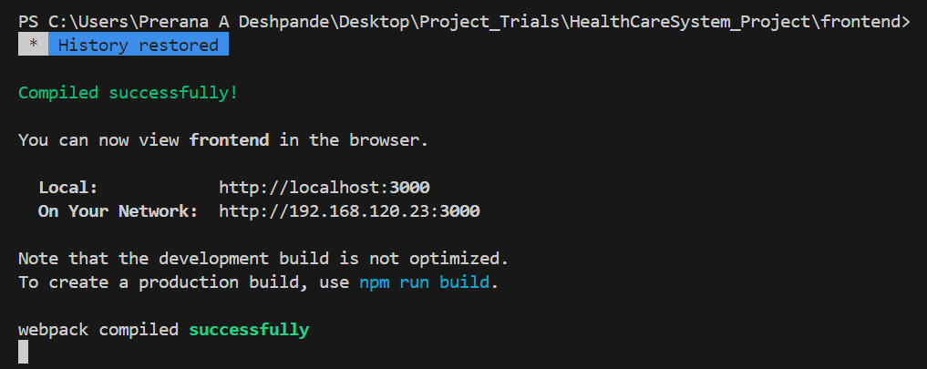

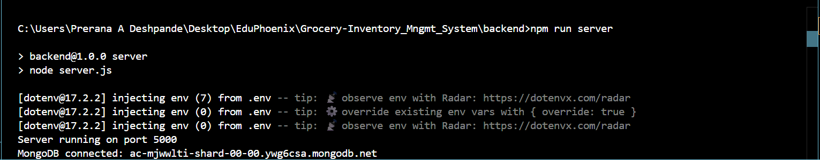

- Welcome Page
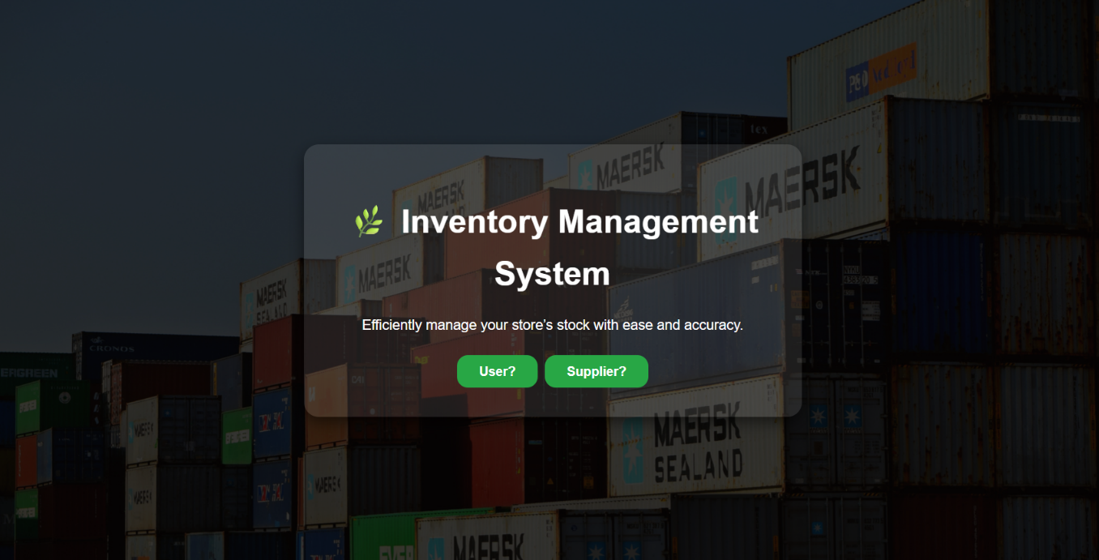

- Login Page
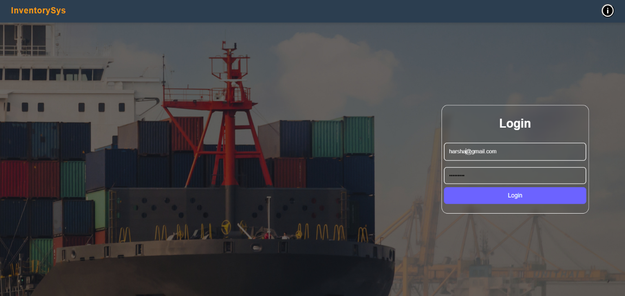

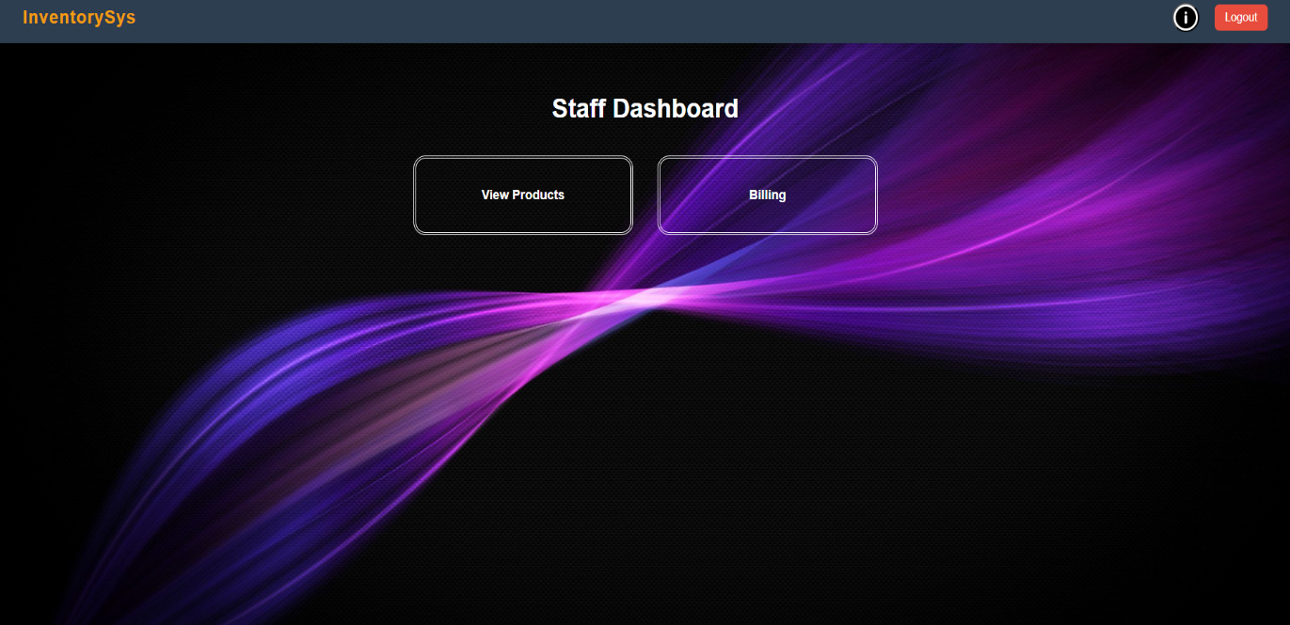

- Billing

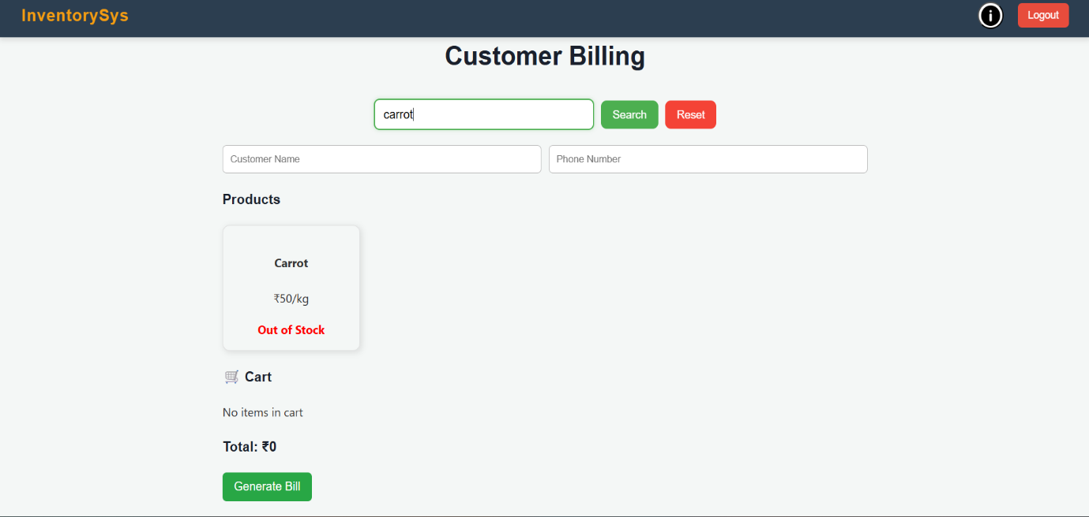

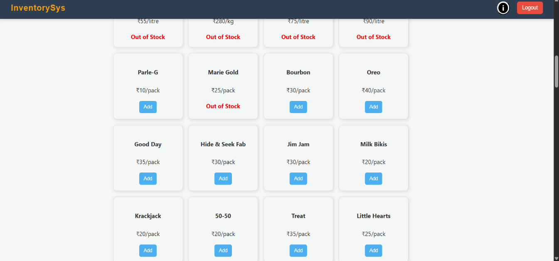

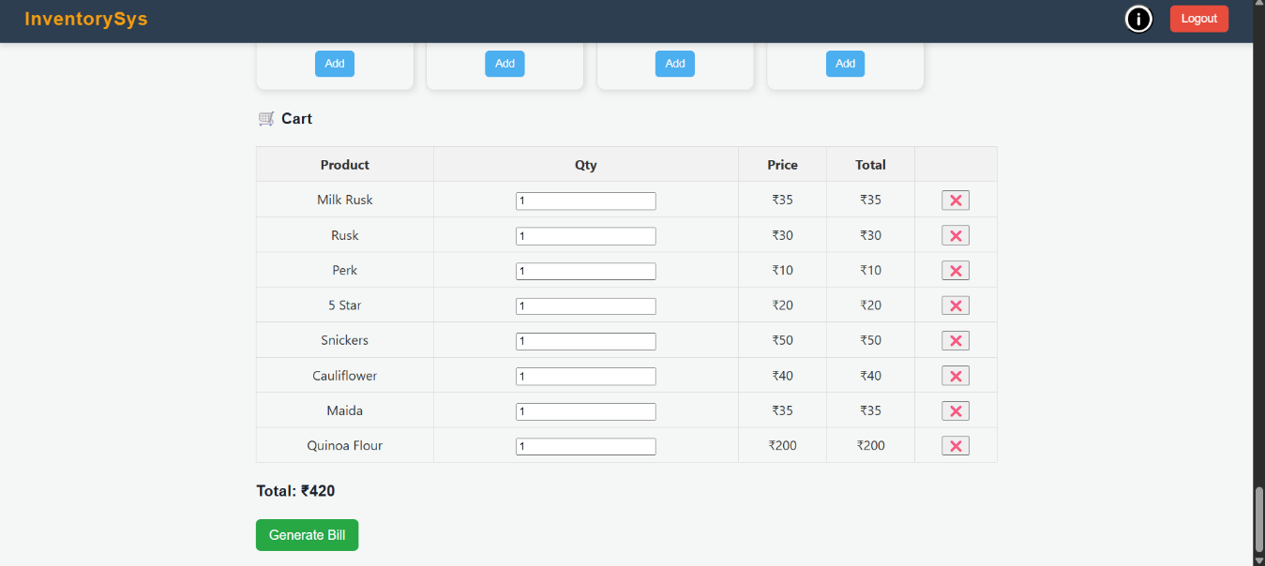

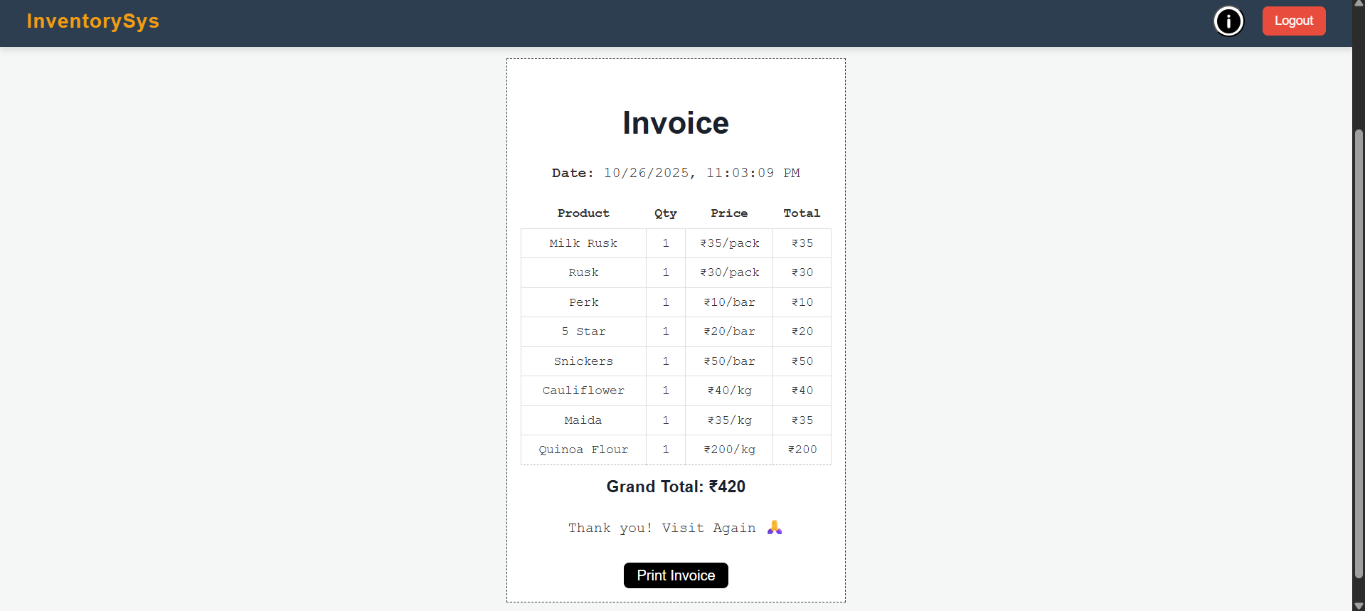

- View Products
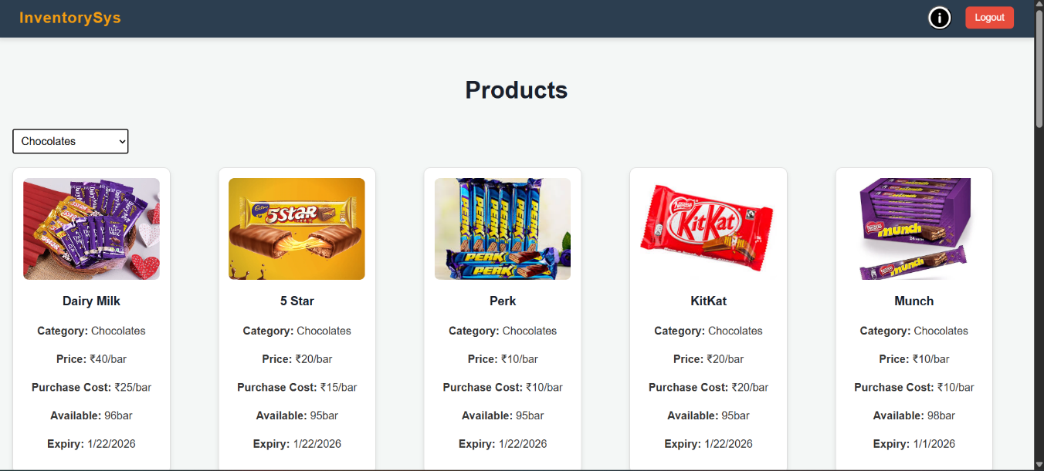

- Supplier Register Page
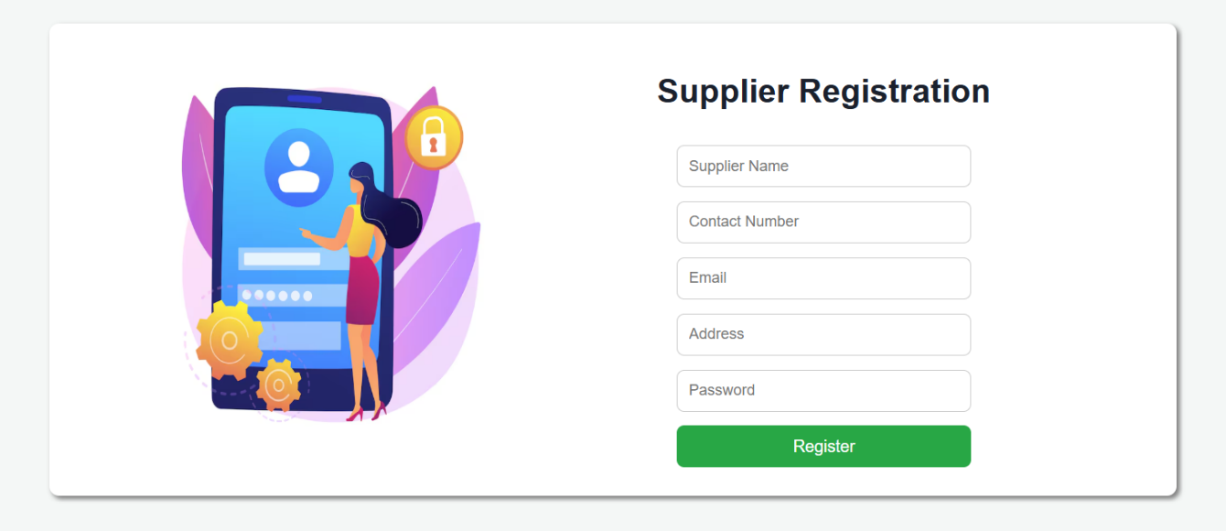

- Supplier Login
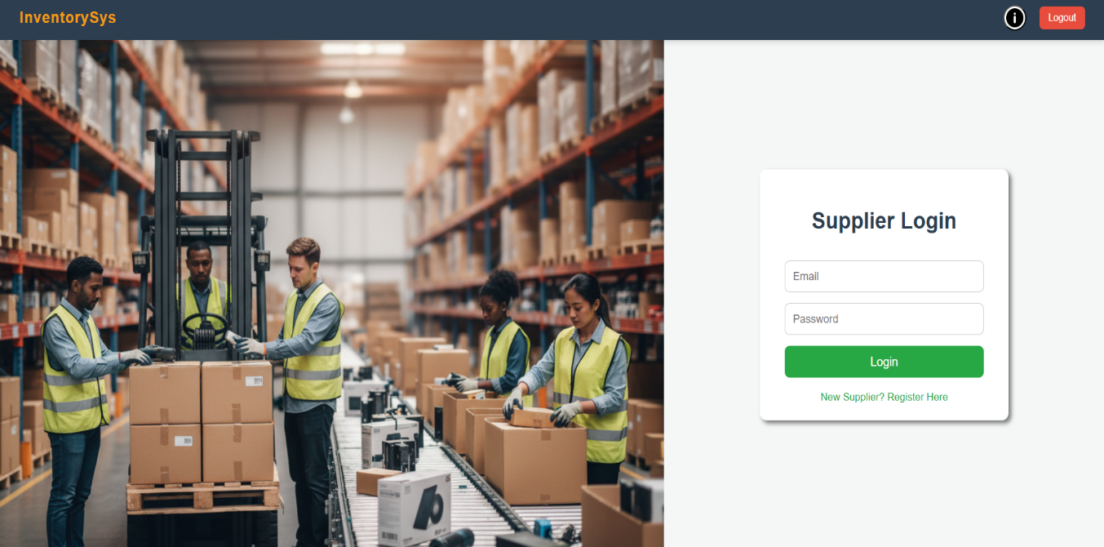

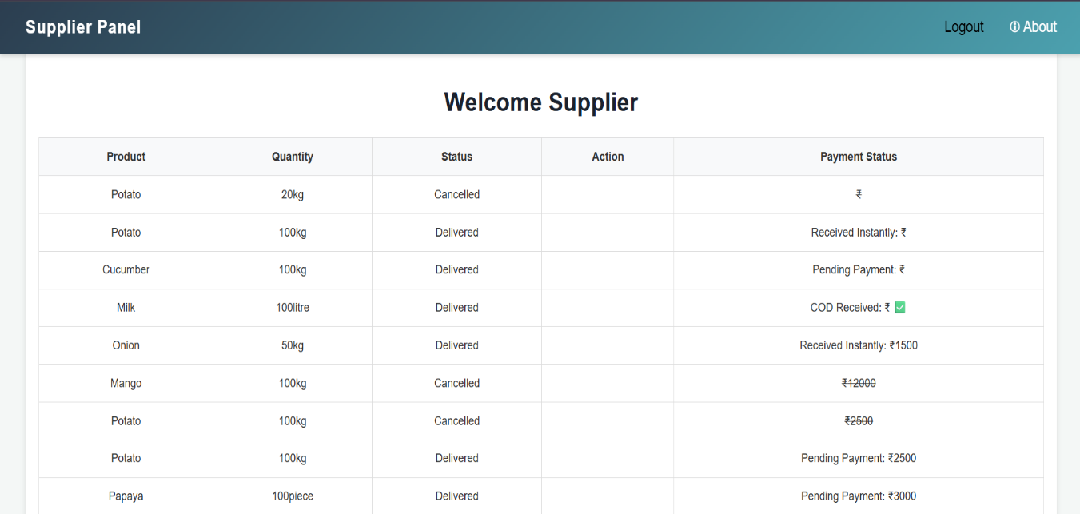

- Admin Dashboard
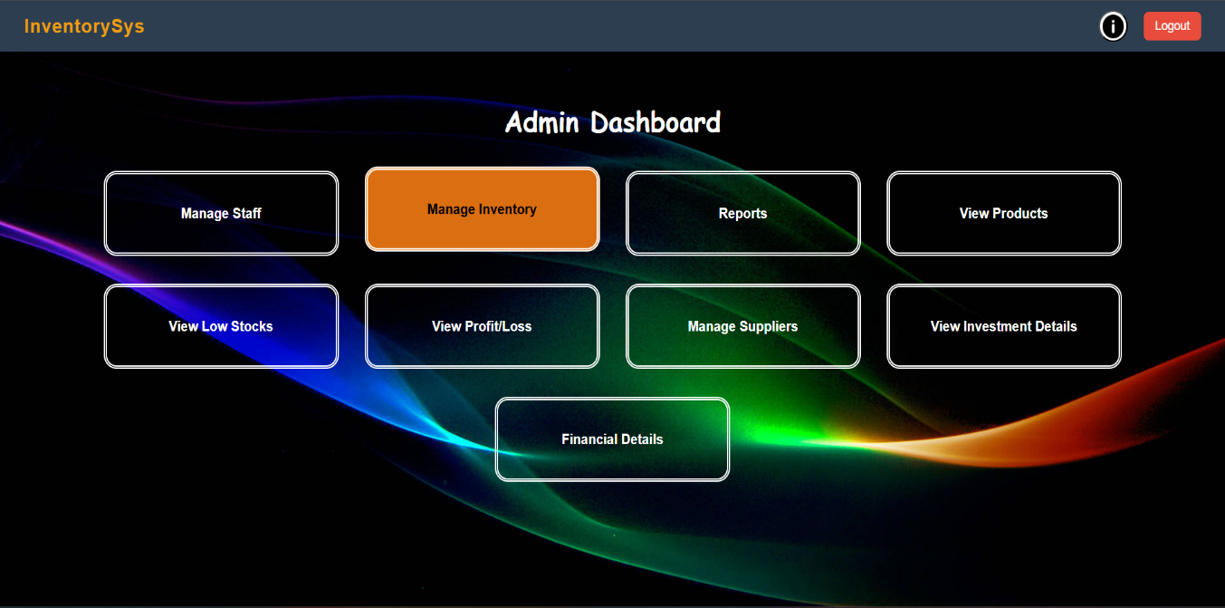

- Manage Staff
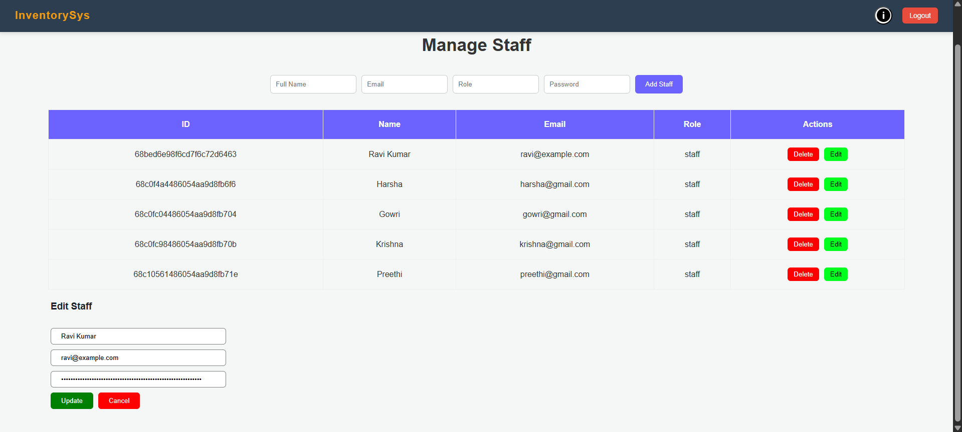

- Manage Inventory
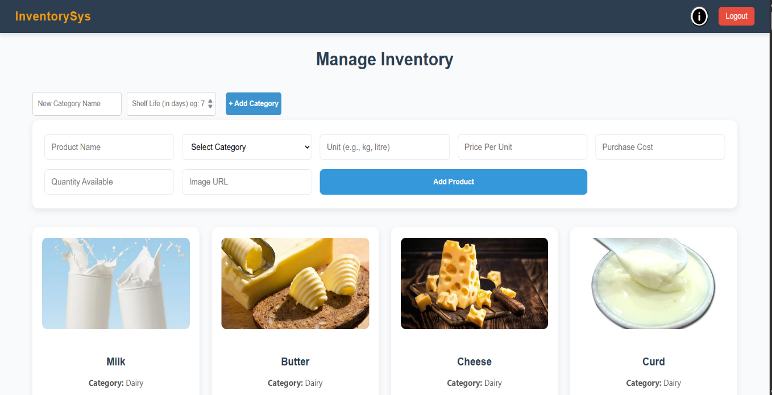

- Responsiveness (After Deployment)
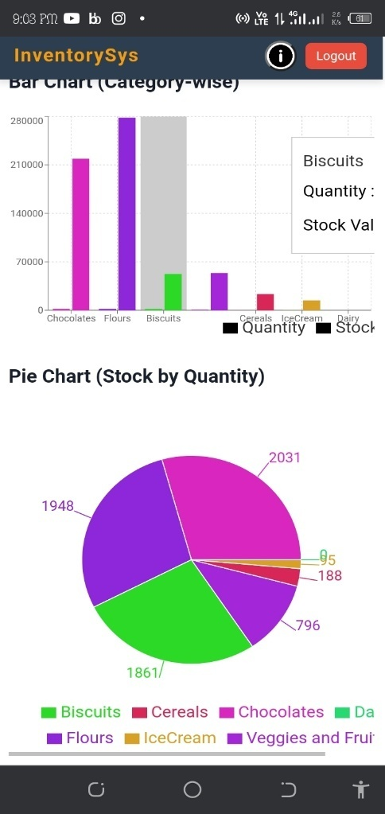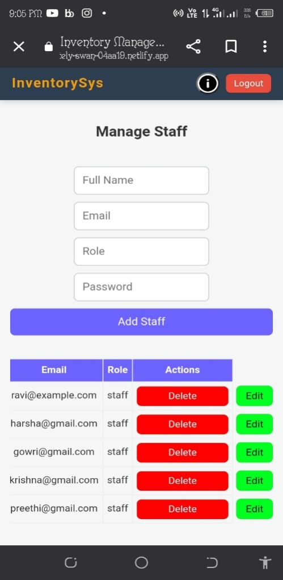
- Restocking Products
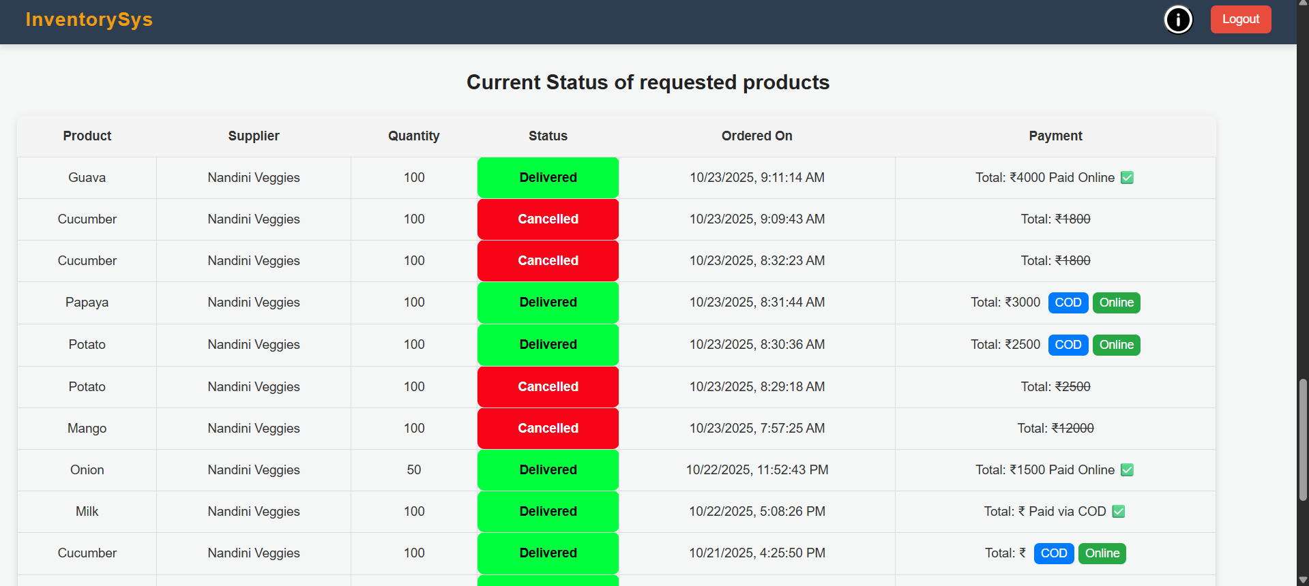
- View Profit/Loss Reports
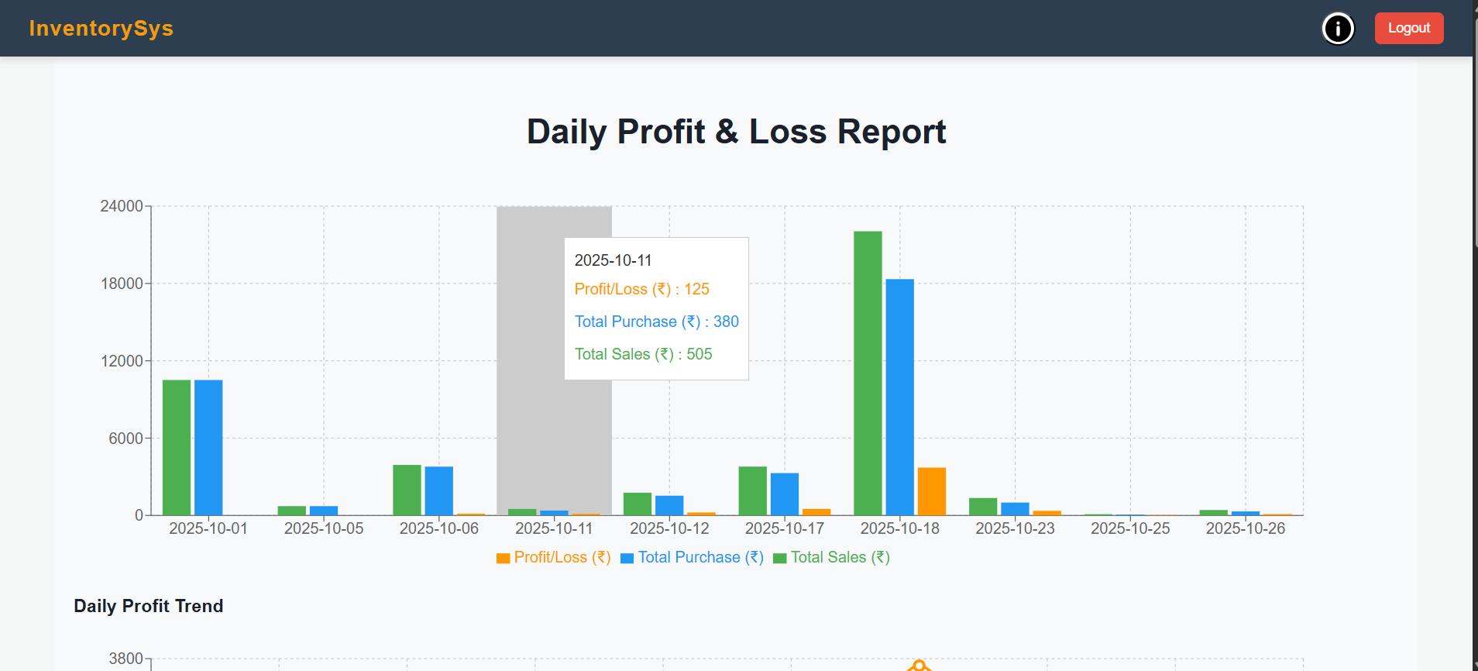

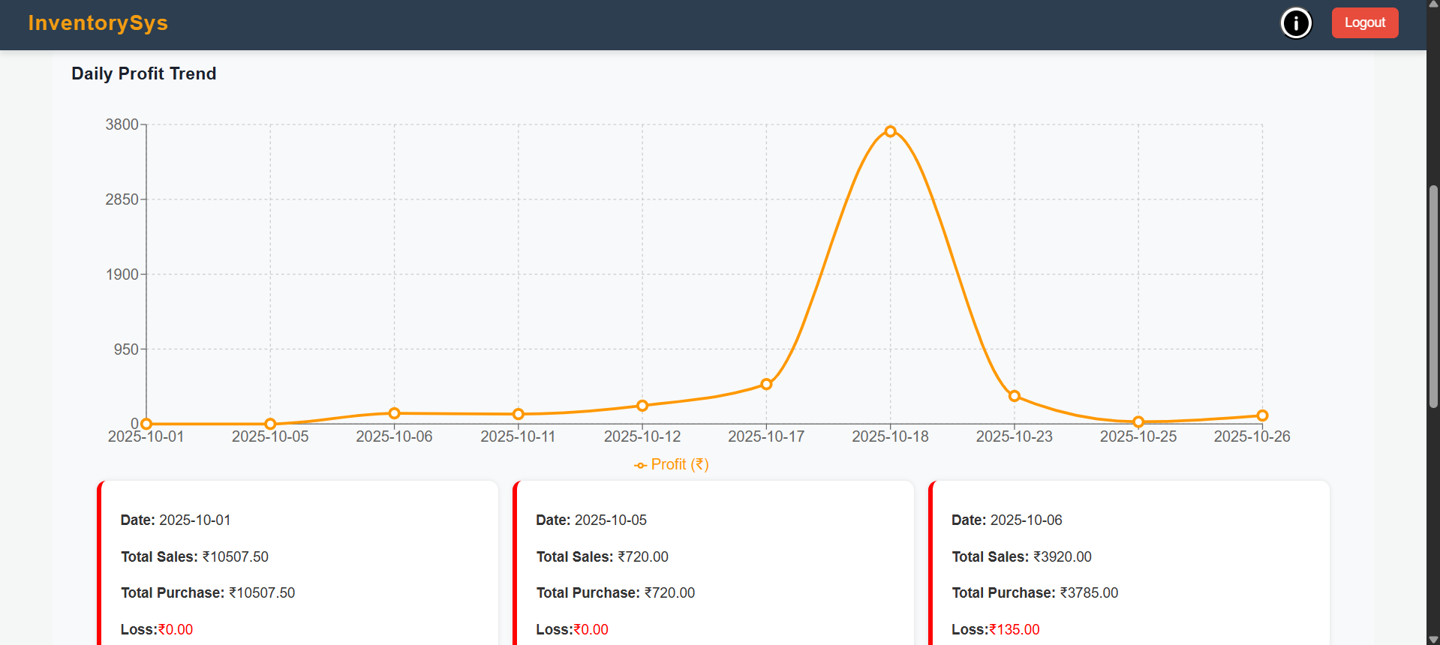

- Manage Suppliers
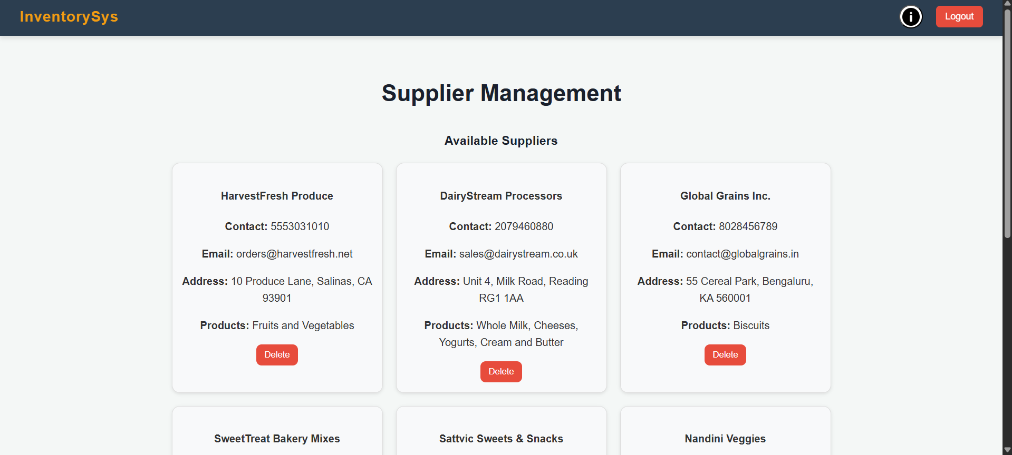

- Investment Details
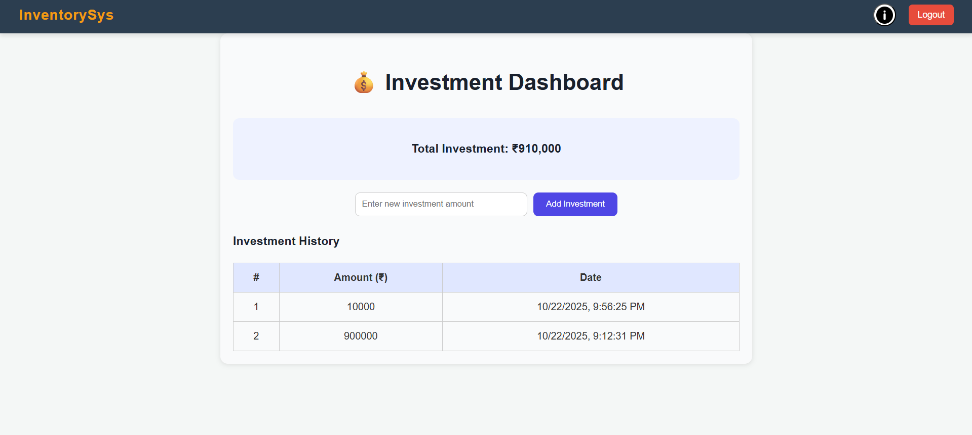

- Financial Report
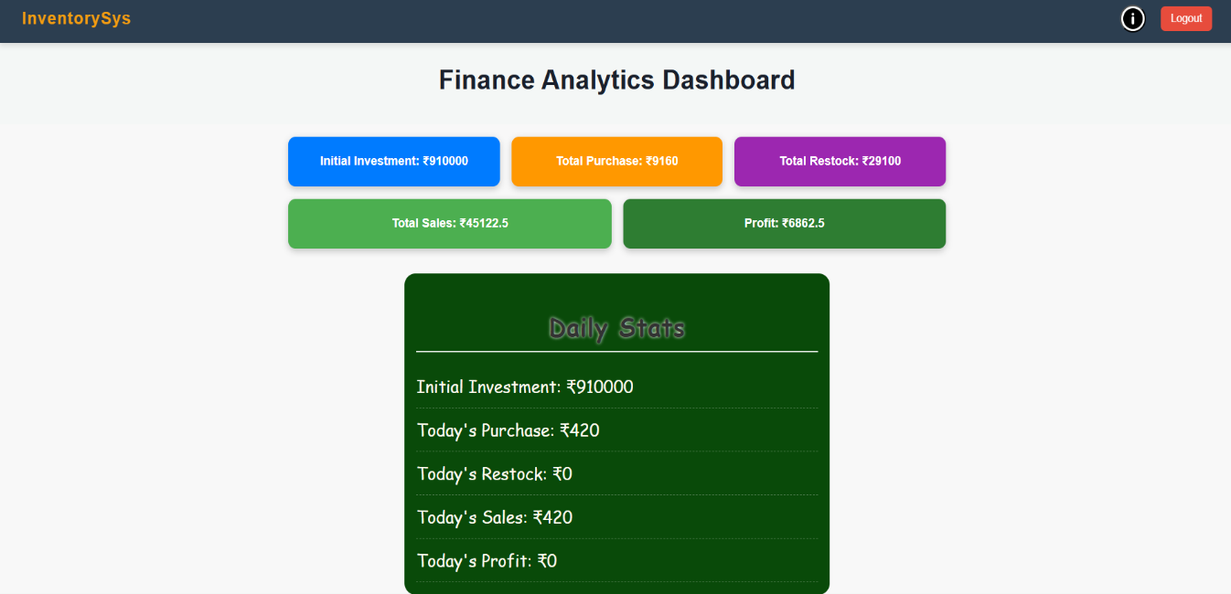

- AboutUs Page
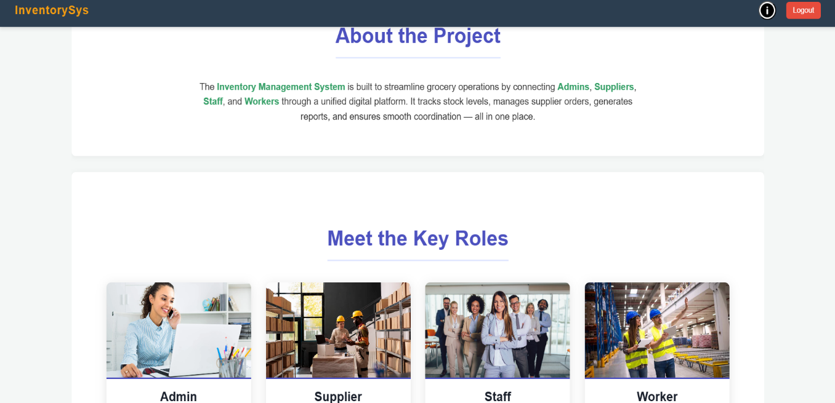

CHAPTER – 6
SYSTEM TESTING

INTRODUCTION
System testing is conducted to verify that the entire Inventory Management System functions as a unified and complete application. The main purpose of this phase is to ensure that every module communicates properly, all business requirements are fulfilled, and the system performs accurately without failures.This phase began only after unit testing and integration testing were successfully completed. During system testing, each feature—from user authentication to billing—was checked to confirm smooth workflow, correct data transfer, and proper enforcement of role-based access.
Types of Testing Performed
Functional Testing
Functional testing was used to confirm that every feature behaves exactly as intended. The focus was on checking input fields, button actions, form validations, navigation, and output results. Core modules such as Login, Inventory Management, Billing, and Supplier Handling were tested for expected performance.
Modules Verified:
- Admin Login: Confirms that only valid admin credentials provide access to the main dashboard.
- Staff Login: Ensures that staff can log in with restricted privileges.
- Product Management: Tests adding, editing, updating, and deleting product records.
- Low Stock List: Displays only the items that have reached minimum quantity.
- Billing System: Calculates totals, generates invoices, updates stock, and stores transaction details correctly.
- Supplier Management: Confirms that restocking requests are received and processed as intended.
Integration Testing Integration testing was executed to validate smooth communication between connected modules.
Example outcomes:
- When the admin adds a product, it must appear instantly in the product list for staff.
- When a product is sold, its stock must update in all relevant screens and the database.
- REST APIs between the frontend and backend were tested to ensure correct request and response flow.
Database Testing Database testing ensured that MongoDB handled all operations with accuracy and consistency. The following checks were performed: 1) New records are inserted correctly. 2) Existing records can be modified or deleted. 3) No duplicated or corrupted data exists.
Security Testing Security testing was done to confirm user authentication, data protection, and restricted access. Major checks included: 1) Only registered users can log in. 2) Admin has full access, while staff can only access limited features. 3) Passwords are encrypted (hashed) before being stored. 4) Unauthorized users cannot access admin panels or sensitive records
UI/UX TestingThe React-based frontend was tested across devices and screen sizes to ensure responsiveness and user-friendly interactions.
What Are Test Cases?
A test case is a predefined set of inputs and steps used to check whether a particular feature is operating correctly.
Each test case has:
- Test Case ID – A unique name/code (e.g., TC01, TC02)
- Description – What you're testing
- Input – What data the user provides
- Expected Output – What should happen
- Actual Output – What actually happened when you tested
- Status – Pass or Fail (based on comparison of expected vs actual)

TEST CASES AND RESULTS
Test Case ID | Description | Input | Expected Output | Actual Output | Status
TC01 | Login | Valid data | Redirect to dashboard | As expected | Pass
TC02 | Login | Invalid credentials | Error message | As expected | Pass
TC03 | Product Management | Add new product | Product appears in inventory | As expected | Pass
TC04 | Billing | Generate Bill | Bill calculated & saved correctly | As expected | Pass
TC05 | Low Stock | View LowStock items | Only low quantity items displayed | As expected | Pass
TC06 | Supplier | Admin sends restock request | Supplier receives request | As expected | Pass
TC07 | Database | Verifying data consistency | Database updated | Asexpected | Pass
TC08 | Security | Unauthorized access | Access denied | Asexpected | Pass

TOOLS USED
- Postman – Used for sending API requests and validating backend responses.
- MongoDB Compass– Utilized for viewing collections and inserting records.
- VS Code Debugger – for backend debugging.
- Browser Developer Tools – Helped in debugging UI issues and testing responsiveness,

BUG TRACKING AND FIXES
Throughout the testing phase, some functional inconsistencies and unexpected errors were identified. Each issue was documented, analyzed, and resolved systematically.
The debugging process included:
- Reproducing the error.
- Finding the exact cause through logs or debugger.
- Applying a fix in the related module.
- Re-testing the updated functionality.
Bug tracking ensured better system stability, improved performance, and a smoother user experience before final deployment.

CHAPTER – 7
CONCLUSION AND FUTURE ENHANCEMENT

CONCLUSION:
The developed Inventory Management System provides an efficient and automated solution for managing stock, billing, and supplier activities in a grocery store setup. It eliminates time-consuming manual entries and ensures information accuracy through real-time updates.
Admins and staff can easily manage daily operations, while suppliers receive timely restock notifications. With integrated modules such as product maintenance, sales processing, supplier management, and low stock alerts, the system offers a complete and user-friendly inventory solution.
By centralizing data, the system reduces human effort, minimizes errors, and improves productivity. It also supports better business decisions by providing accurate and organized information.

FUTURE ENHANCEMENT:
Although the existing system meets the required functionality, several advanced features can be added to make it more powerful and scalable. Possible future improvements include:
- Barcode or QR scanning for fast product entry
- AI-driven demand forecasting to automate purchasing decisions
- Graphical dashboards displaying sales analytics and profit trends
- Multi-store management under a unified login
- Email or SMS notifications for low stock or supplier responses
- A mobile application for real-time access on smartphones
- Cloud-based backup and data recovery for enhanced security
- Implementing these enhancements would increase system intelligence, flexibility, and suitability for larger business environments.

CHAPTER – 8
BIBLIOGRAPHY

- WEB RESOURCES
• React Documentation – https://reactjs.org/docs/getting-started.html • Node.js Official Docs – https://nodejs.org/en/docs • Express.js Documentation – https://expressjs.com/ • MySQL Documentation – https://dev.mysql.com/doc/ •W3Schools – HTML, CSS, JavaScript Tutorials – https://www.w3schools.com/• MDN Web Docs – https://developer.mozilla.org/• GeeksforGeeks – https://www.geeksforgeeks.org/ • StackOverflow – https://stackoverflow.com/questions •ChatGPT –Assistance with code debugging and report writing –https://chat.openai.com/

